Wheel of Fortune In Exercises 35–38, use the small replica of the Wheel of Fortune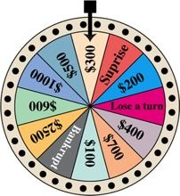

If the wheel is spun at random, determine the probability of the sector indicated stopping under the pointer
38.
$2500 or Surprise

14.Career Fair Attendance For a Nursing and Allied Health Care Career Fair, organizers estimate that 50 people will attend if it does not rain and 65 will attend if it rains. The weather forecast indicates that there is a 40% chance it will not rain and a 60% chance it will rain on the day of the career fair. Determine the expected number of people who will attend the fair.

