Scheduling (production processes)
From Wikipedia, the free encyclopedia
Jump to: navigation, search
Scheduling is an important tool for manufacturing and engineering, where it can have a major impact on the productivity of a process. In manufacturing, the purpose of scheduling is to minimize the production time and costs, by telling a production facility when to make, with which staff, and on which equipment. Production scheduling aims to maximize the efficiency of the operation and reduce costs.
Production scheduling tools greatly outperform older manual scheduling methods. These provide the production scheduler with powerful graphical interfaces which can be used to visually optimize real-time work loads in various stages of production, and pattern recognition allows the software to automatically create scheduling opportunities which might not be apparent without this view into the data. For example, an airline might wish to minimize the number of airport gates required for its aircraft, in order to reduce costs, and scheduling software can allow the planners to see how this can be done, by analyzing time tables, aircraft usage, or the flow of passengers.
Companies use backward and forward scheduling to allocate plant and machinery resources, plan human resources, plan production processes and purchase materials.
Forward scheduling is planning the tasks from the date resources become available to determine the shipping date or the due date.
Backward scheduling is planning the tasks from the due date or required-by date to determine the start date and/or any changes in capacity required.
The benefits of production scheduling include:
- Process change-over reduction
- Inventory reduction, leveling
- Reduced scheduling effort
- Increased production efficiency
- Labor load leveling
- Accurate delivery date quotes
- Real time information

Contents
[hide]
- 1 Productivity
  - 1.1 Inputs
  - 1.2 Outputs
    - 1.2.1 Within the factory
    - 1.2.2 For the next factory
    - 1.2.3 For the end buyer
  - 1.3 Resource allocation
- 2 Scheduling Algorithms
  - 2.1 Stochastic Algorithms
  - 2.2 Heuristic Algorithms
- 3 Batch Production Scheduling
  - 3.1 Background
  - 3.2 Scheduling in the Batch Processing Environment
  - 3.3 Cycle-Time Analysis
  - 3.4 Visualization
  - 3.5 Algorithmic Methods
- 4 Notes
- 5 Additional References
- 6 See also
- 7 External links

[edit] Productivity
Productivity is the relation between quantity of inputs and quantity of output.

[edit] Inputs
Inputs are plant, labor, materials, tooling, energy and a clean environment.

[edit] Outputs
Outputs are the products produced in factories either for other factories or for the end buyer. The extent to which any one product is produced within any one factory is governed by transaction cost.

[edit] Within the factory
The output of any one work area within the factory is an input to the next work area in that factory according to the manufacturing process. For example the output of the cutting room is an input to the sewing room.

[edit] For the next factory
By way of example, the output of a paper mill is an input to a print factory. The output of a petrochemicals plant is an input to an asphalt plant, a cosmetics factory and a plastics factory.

[edit] For the end buyer
Factory output goes to the consumer via a service business such as a retailer or an asphalt paving company.

[edit] Resource allocation
Resource allocation is assigning inputs to produce output. The aim is to maximize output with given inputs or to minimize quantity of inputs to produce required output.

[edit] Scheduling Algorithms
Main article: Genetic Algorithm Scheduling
See also: Job Shop Scheduling
Production scheduling can take a significant amount of computing power if there are a large number of tasks. Therefore a range of short-cut algorithms (heuristics) (a.k.a. dispatching rules) are used:

[edit] Stochastic Algorithms
- Economic Lot Scheduling Problem
- Economic production quantity

[edit] Heuristic Algorithms
- Modified due date scheduling heuristic
- Shifting bottleneck heuristic

[edit] Batch Production Scheduling

[edit] Background
Batch production scheduling is the practice of planning and scheduling of batch manufacturing processes. See Batch production. Although, scheduling may apply to traditionally continuous processes, such as refining ^{[1][2]}, it is especially important for batch processes such as those for pharmaceutical active ingredients, biotechnology processes and many specialty chemical processes ^{[3][4]}. Batch production scheduling shares some concepts and techniques with finite capacity scheduling which has been applied to many manufacturing problems ^{[5]}. The specific issues of scheduling batch manufacturing processes have generated considerable industrial and academic interest.

[edit] Scheduling in the Batch Processing Environment
A batch process can be described in terms of a recipe which comprises a bill of materials and operating instructions which describe how to make the product. ^{[6]} The ISA S88 batch process control standard ^{[7]} provides a framework for describing a batch process recipe. The standard provides a procedural hierarchy for a recipe. A recipe may be organized into a series of unit-procedures or major steps. Unit-procedures are organized into operations, and operations may be further organized into phases.
The following text-book recipe ^{[8]} illustrates the organization.
- Charge and Mix materials A and B in a heated reactor, heat to 80C and react 4 hours to form C.
- Transfer to blending tank, add solvent D, Blend 1hour. Solid C precipitates.
- Centrifuge for 2 hours to separate C.
- Dry in a tray dryer for 1 hour.
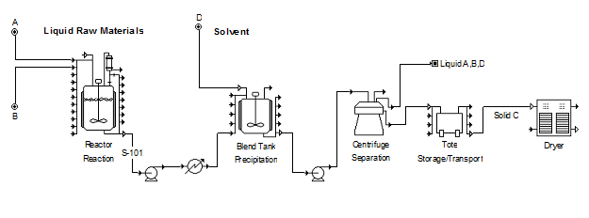
A simplified S88-style procedural organization of the recipe might appear as follows:
- Unit Procedure 1: Reaction
  - Operation 1: Charge A & B (0.5 hours)
  - Operation 3: Blend / Heat (1 hour)
  - Operation 4: Hold at 80C for 4 hours
  - Operation 5: Pump solution through cooler to blend tank (0.5 hours)
  - Operation 5: Clean (1 hour)
- Unit Procedure 2: Blending Precipitation
  - Operation 1: Receive solution from reactor
  - Operation 2: Add solvent, D (0.5 hours)
  - Operation 3: Blend for 2 hours
  - Operation 4: Pump to centrifuge for 2 hours
  - Operation 5: Clean up (1 hour)
- Unit Procedure 3: Centrifugation
  - Operation 1: Centrifuge solution for 2 hours
  - Operation 2: Clean
- Unit Procedure 4: Tote
  - Operation 1: Receive material from centrifuge
  - Operation 2: Load dryer (15 min)
- Unit Procedure 5: Dry
  - Operation 1: Load
  - Operation 2: Dry (1 hour)
Note that the organization here is intended to capture the entire process for scheduling. A recipe for process-control purposes may have a more narrow scope.
Most of the constraints and restrictions described by Pinedo^{[9]} are applicable in batch processing. The various operations in a recipe are subject to timing or precedence constraints that describe when they start and or end with respect to each other. Furthermore, because materials may be perishable or unstable, waiting between successive operations may be limited or impossible. Operation durations may be fixed or they may depend on the durations of other operations.
In addition to process equipment, batch process activities may require labor, materials, utilities and extra equipment.

[edit] Cycle-Time Analysis
In some simple cases, an analysis of the recipe can reveal the maximum production rate and the rate limiting unit. In the process example above if a number of batches or lots of Product C are to be produced, it is useful to calculate the minimum time between consecutive batch starts (cycle-time). If a batch is allowed to start before the end of the prior batch the minimum cycle-time is given by the following relationship ^{[10]}:
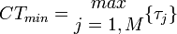
Where CT_{min} is the shortest possible cycle time for a process with M unit-procedures and τ_{j} is the total duration for the jth unit-procedure. The unit-procedure with the maximum duration is sometimes referred to as the bottleneck. This relationship applies when each unit-procedure has a single dedicated equipment unit.
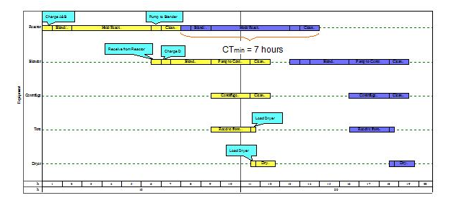
If redundant equipment units are available for at least one unit-procedure, the minimum cycle-time becomes:
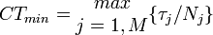
Where N_{j} is the number of redundant equipment for unit procedure j.
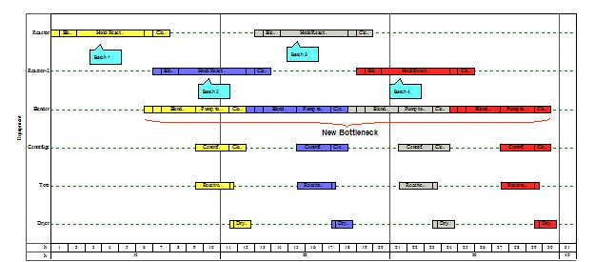
If equipment is reused within a process, the minimum cycle-time becomes more dependent on particular process details. For example, if the drying procedure in the current example is replaced with another reaction in the reactor, the minimum cycle time depends on the operating policy and on the relative durations of other procedures. In the cases below, and increase in the hold time in the tote can decrease the average minimum cycle time.
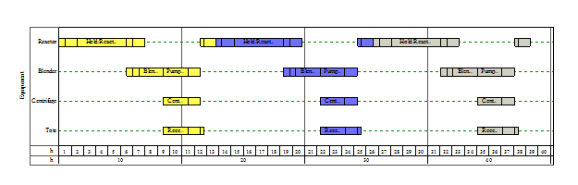
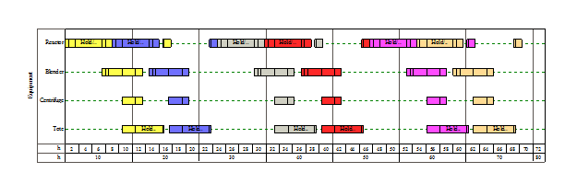

[edit] Visualization
Various charts are used to help schedulers visually manage schedules and constraints. The Gantt chart is a display that shows activities on a horizontal bar graph in which the bars represent the time of the activity. Below is an example of a Gantt chart for the process in the example described above.
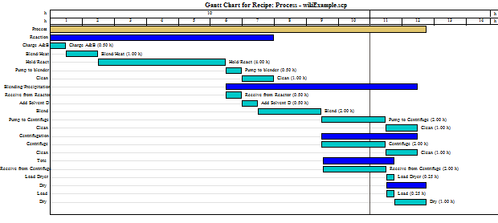
Another time chart which also sometime called a Gantt chart^{[11]} shows the time during which key resources, e.g. equipment, are occupied. The previous figures show this occupancy-style Gantt chart.
Resources that are consumed on a rate basis, e.g. electrical power, steam or labor, are generally displayed as consumption rate vs time plots.
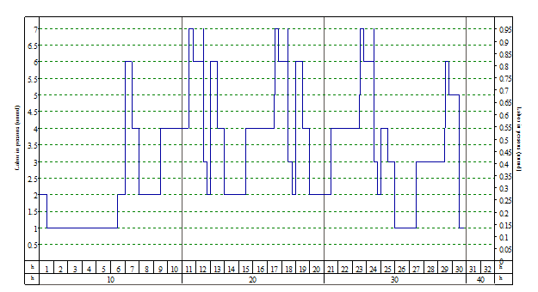

[edit] Algorithmic Methods
When scheduling situations become more complicated, for example when two or more processes share resources, it may be difficult to find the best schedule. A number of common scheduling problems, including variations on the example described above, fall into a class of problems that become very difficult to solve as their size (number of procedures and operations) grows^{[12]}.
A wide variety of algorithms and approaches have been applied to batch process scheduling. Early methods, which were implemented in some MRP systems assumed infinite capacity and depended only on the batch time. Such methods did not account for any resources would produce infeasible schedules.^{[13]}
Mathematical programming methods involve formulating the scheduling problem as an optimization problem where some objective, e.g. total duration, must be minimized (or maximized) subject to a series of constraints which are generally stated as a set of inequalities and equalities. The objective and constraints may involve zero-or-one (integer) variables as well as nonlinear relationships. An appropriate solver is applied for the resulting mixed-integer linear or nonlinear programming (MILP/MINLP) problem. The approach is theoretically guaranteed to find an optimal solution if one exists. The disadvantage is that the solver algorithm may take an unreasonable amount of time. Practitioners may use problem-specific simplifications in the formulation to get faster solutions without eliminating critical components of the scheduling model. ^{[14]}
Constraint programming is a similar approach except that the problem is formulated only as a set of constraints and the goal is to arrive at a feasible solution rapidly. Multiple solutions are possible with this method.^{[15][16]}

[edit] Notes
- ^ Marcus V. Magalhaes and Nilay Shah, “Crude Oil Scheduling,” Foundations of Computer-Aided Operations (FOCAPO) 2003,pp 323-325.
- ^ Zhenya Jia and Marianthi Ierapetritou, “Efficient Short-Term Scheduling of Refinery Operation Based on a Continuous Time Formulation,” Foundations of Computer-Aided Operations (FOCAPO) 2003, pp 327-330
- ^ Toumi, A., Jurgens, C., Jungo, C., MAier, B.A., Papavasileiou, V., and Petrides, D., “Design and Optimization of a Large Scale Biopharmaceutical Facility using Process Simulation and Scheduling Tools,” Pharmaceutical Engineering (the ISPE magazine) 2010, vol 30, no 2, pp 1-9.
- ^ Papavasileiou, V., Koulouris, A., Siletti, C., and Petrides, D., “Optimize Manufacturing of Pharmaceutical Products with Process Simulation and Production Scheduling Tools,” Chemical Engineering Research and Design (IChemE publication) 2007, vol 87, pp 1086-1097
- ^ Michael Pinedo, Scheduling Theory, Algorithms, and Systems,Prentice Hall, 2002,pp 1-6.
- ^ T. F. Edgar, C.L. Smith, F. G. Shinskey, G. W. Gassman, P. J. Schafbuch, T. J. McAvoy, D. E. Seborg, Process Control, Perry’s Chemical Engineer’s Handbook, R. Perry and D. W. Green eds.,McGraw Hill, 1997,p 8-41.
- ^ Charlotta Johnsson, S88 for Beginners, World Batch Forum, 2004.
- ^ L.T. Biegler, I. E. Grossman and A. W. Westerberg, Systematic Methods of Chemical Process Design, Prentice Hall, 1999 p181.
- ^ M. Pinedo, 2002, pp 14-22.
- ^ Biegler et al. 1999, p187
- ^ M. Pinedo, 2002, p430
- ^ M. Pinedo, 2002, p28
- ^ G. Plenert and G/ Kirchmier, 2000, pp38-41
- ^ C. Mendez, J. Cerda, I. Grossman, I. Harjunkoski, M. Fahl, State of the art Review of Optimization Methods for Short Term Scheduling of Batch Processes, Computers and Chemical Engineering, 30 (2006), pp 913-946
- ^ I. Lustig, Progress in Linear and Integer Programming and Emergence of Constraint Programming, Foundations of Computer-Aided Operations (FOCAPO) 2003, 133-151
- ^ L. Zeballos and G.P. Henning, A Constraint Programming Approach to the Multi-Stage Batch Scheduling Problem, Foundations of Computer-Aided Operations (FOCAPO), 2003, 343-346

[edit] Additional References
- Blazewicz, J., Ecker, K.H., Pesch, E., Schmidt, G. und J. Weglarz, Scheduling Computer and Manufacturing Processes, Berlin (Springer) 2001, ISBN 3-540-41931-4
- Herrmann, Jeffrey W., editor, 2006, Handbook of Production Scheduling, Springer, New York.
- McKay, K.N., and Wiers, V.C.S., 2004, Practical Production Control: a Survival Guide for Planners and Schedulers, J. Ross Publishing, Boca Raton, Florida. Co-published with APICS.
- Pinedo, Michael L. 2005. Planning and Scheduling in Manufacturing and Services, Springer, New York.

Scheduling

McGraw-Hill Science & Technology Dictionary:

scheduling
Ads
Aesopwww.aesopscheduling.com
Automated Rostering and Fulfillment For Assisted Living Organizations
SodeaSoft Planning Pro 7www.sodeasoft.com
Gestion du Personnel, Agenda commun Version d'essai ,vidéos et Freeware
Home > Library > Science > Sci-Tech Dictionary
(′skej·əl·iŋ)
(industrial engineering) A decision-making function that plays an important role in most manufacturing and service industries and often allows an organization to operate with a minimum of resources. Scheduling is applied in procurement and production, in transportation and distribution, and in information processing and communication. In manufacturing, the scheduling function coordinates the flow of parts and products through the system, and balances the workload on machines and personnel, departments, and the entire plant.

English▼
English▼ Deutsch Español Français Italiano Tagalog

Search unanswered questions...

- Browse: Unanswered questions | Most-recent questions | Reference library

Enter question or phrase...
Search: All sources Community Q&A Reference topics
- Browse: Unanswered questions | New questions | New answers | Reference library

Ads
Zanager Scheduling Systemaladtec.com
Interactive employee scheduling system - Try our free demo today
Schedulesyahoo.com
Looking for Schedules? Find exactly what you want today.

Related Videos:

Scheduling
Top
Click to Play
IPhone MyCentrl App Review
Click to Play
How to Schedule Meetings Online Using GoToMeeting
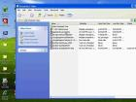Click to Play
Schedule Tasks in Windows
Click to Play
How to use Microsoft Office - Scheduling a Meeting with Outlook

View more Technology videos

McGraw-Hill Science & Technology Encyclopedia:

Scheduling
Top
Home > Library > Science > Sci-Tech Encyclopedia
A decision-making function that plays an important role in most manufacturing and service industries. Scheduling is applied in procurement and production, in transportation and distribution, and in information processing and communication. A scheduling function typically uses mathematical optimization techniques or heuristic methods to allocate limited resources to the processing of tasks.
Project scheduling is concerned with a set of activities that are subject to precedence constraints, specifying which jobs have to be completed before a given job is allowed to start its processing. All activities belong to a single (and typically large) project that has to be completed in a minimum time; for example, a large real estate development or the construction of an aircraft carrier.
Production or job shop scheduling is important in manufacturing settings, for example, semiconductor manufacturing. Customer orders have to be executed. Each order entails a number of operations that have to be processed on the resources or the machines available. Each order has a committed shipping date that plays the role of a due date. Production scheduling often also includes lot sizing and batching.
Timetabling occurs often in class room scheduling, scheduling of meetings, and reservation systems. In many organizations, especially in the service industries, meetings must be scheduled in such a way that all necessary participants are present; often other constraints have to be satisfied as well (in the form of space and equipment needed). Such problems occur in schools with classroom and examination scheduling as well as in the renting of hotel rooms and automobiles.
Work-force scheduling (crew scheduling, and so on) is increasingly important, especially in the service industries. For example, large call centers in many types of enterprises (airlines, financial institutions, and others) require the development of complicated personnel scheduling techniques.
In order to determine satisfactory or optimal schedules, it is helpful to formulate the scheduling problem as a mathematical model. Such a model typically describes a number of important characteristics. One characteristic specifies the number of machines or resources as well as their interrelationships with regard to the configuration, for example, machines set up in series, machines set up in parallel. A second characteristic of a mathematical model concerns the processing requirements and constraints. These include setup costs and setup times, and precedence constraints between various activities. A third characteristic has to do with the objective that has to be optimized, which may be a single objective or a composite of different objectives. For example, the objective may be a combination of maximizing throughput (which is often equivalent to minimizing setup times) and maximizing the number of orders that are shipped on time.
The scheduling function is often incorporated in a system that is embedded in the information infrastructure of the organization. This infrastructure may be an enterprise-wide information system that is connected to the main databases of the company. Many other decision support systems may be plugged into such an enterprise-wide information system—for example, forecasting, order promising and due date setting, and material requirements planning (MRP).
The database that the scheduling system relies on usually has some special characteristics. It has static data as well as dynamic data. The static data—for example, processing requirements, product characteristics, and routing specifications—are fixed and do not depend on the schedules developed. The dynamic data are schedule-dependent; they include the start times and completion times of all the operations on all the different machines, and the length of the setup times (since these may also be schedule-dependent).
The economic impact of scheduling is significant. In certain industries the viability of a company may depend on the effectiveness of its scheduling systems, for example, airlines and semiconductor manufacturing. Good scheduling often allows an organization to conduct its operations with a minimum of resources. See also Material resource planning; Production planning.

Oxford Dictionary of Archaeology:

Scheduling
Top
Home > Library > Science > Archaeology Dictionary
[Le]
In the British Isles the legal protection of archaeological sites involves the selection of nationally important examples which are then added to an official list or Schedule. The process is known as Scheduling; monuments protected in this way are known as Scheduled Monuments or, incorrectly, Scheduled Ancient Monuments (SAMs). To be protected in this way a monument must be judged to be of national importance according to the following criteria: period; rarity; documentation; group value; survival/condition; fragility/vulnerability; diversity; and potential. There is no appeal against the Scheduling process which defines an area of land containing the archaeological site known as the Scheduled Area. Protection takes the form of controlling works within the Scheduled Area; before any works are carried out within a Scheduled Area, Scheduled Monument Consent (SMC) from the Secretary of State is required. Damaging a Scheduled Monument or undertaking works without consent is a criminal offence.

Gale Encyclopedia of Education:

Scheduling
Top
Home > Library > History, Politics & Society > Education Encyclopedia
In 1994 the National Education Commission on Time and Learning found the issue of how time is spent in schools to be a matter of urgency. Likewise, the National Education Association reported that "across the nation in schools and districts engaged in transforming schools into more effective learning communities, the issue that has emerged as the most intense and the one that universally dominates discussion is time" (p. 9). To spend the "time budget" more wisely, schools use a variety of scheduling arrangements. Discussed here are the various types of schedules that schools use to make optimum use of the school day.
Historical Background of Scheduling
In the early nineteenth century, teachers typically had a limited education and were expected to function well in all subject areas. Staff at all levels taught any subject at any time of the day. In the late 1800s, the Carnegie unit - comprised of approximately fifty-minute class periods in which a single subject is taught, and for which teachers specialize in particular subject areas - became the most frequently used scheduling format. J. Lloyd Trump's An Image of the Future, published in 1958, caused schools to experiment with ungraded instruction, long periods of independent study, and large group instruction. The plan failed, however, partly due to the large amount of unstructured, independent study time for students.
Other scheduling experiments have also failed. In the 1970s, the notion that flexibility in scheduling is beneficial to staff and students led to the Open School concept. Divisions between classrooms in elementary schools were eliminated and students were able to progress at their own speed, moving from one grade area to another. During the 1960s and 1970s, some schools modified the traditional seven-period day, breaking the day up into twenty-minute modules and calling the plan modular flexible scheduling. Neither plan took hold.
In the 1970s, with flexibility continuing to be a priority, fluid block scheduling became popular and successful. This scheduling pattern allots a block of two to three hours to teams of teachers from various subject areas, allowing teachers to schedule instruction according to student needs. Another flexible scheduling alternative that began in the late 1980s and continues in popularity is the zero period schedule. Designated courses begin an hour earlier than the regular school day, allowing some students to leave an hour earlier or enroll in an extra class.
The 1989 publication of Turning Points, by the Carnegie Council on Adolescent Development, brought major changes for middle-level schools. Recognizing that junior high schools were simply mirror images of high schools, the council recommended that schools be reconfigured to fit the developmental needs of young adolescents. Thus, various forms of block scheduling and interdisciplinary teaming took hold in middle schools, and later in high schools as well. With block scheduling, teachers are given longer periods of time - usually ninety minutes - to work with students. Interdisciplinary teaming is a popular arrangement where a group of teachers (usually four or five) works with 125 to 150 students, essentially creating a school within a school. Interdisciplinary units of study help students' understand the connections between subjects. Teaming is sometimes combined with block scheduling.
Throughout the history of school scheduling, the need for flexibility and the need for teachers to work cooperatively for the benefit of students are recurring themes. These themes impact educators' scheduling choices.
Selecting a Schedule
Selecting an appropriate school schedule involves some fundamental assessments, including examining what teachers are doing and determining if classroom instruction is improving student achievement. When teachers make instruction optimally effective for students, it is appropriate to consider how use of time could further enhance learning - the schedule must support, not drive, the instructional program. As teachers become more innovative and experimental in their classroom activities, they adopt flexible and cooperative approaches that demand new organizational arrangements.
What students need is another consideration when choosing a schedule. For example, elementary and middle school students are restless, have short attention spans, and require frequent physical movement, and frequently changing settings allows for such movement. Elementary students need close relationships with adults, and thus need to remain in the care of one teacher, not five or six, during a school day. High school students need opportunities to explore more specialized areas of interest, and thus require a wide variety of courses from which to choose.
Other considerations can impact scheduling. Whether or not to group students by their ability levels is an issue on which parents and teachers do not always agree. If improving student behavior is a priority, reducing the number of times students change classes and interact in the halls is considered. Teachers' preferences for teaching assignments and planning periods, assigning enough lunch periods to accommodate students, arranging for televised classes, including courses that are popular (or eliminating outdated ones), and parents' attitudes about courses all impact scheduling decisions.
Scheduling Models
Scheduling models are generally described in terms of the amount of time students spend in a specified classroom. The most frequently used scheduling models are (a) the traditional, self-contained classroom, (b) forty-five to fifty-minute class periods, (c) a variety of configurations of block scheduling, and (d) teaming.
Self-contained classrooms. Typically seen in elementary schools, self-contained classrooms are settings where a single teacher is in charge of instructing twenty to thirty students for the major portion of the day. The advantages of self-contained classrooms include strong student-teacher and student-to-student relationships; flexibility in time spent on subject areas; and buildings designed for self-contained classes. The cost of this arrangement is in the loss of high-quality instruction for some subject areas, and possibly in all subjects, if the teacher is not a master of instruction and discipline.
Forty-five to fifty-minute class periods. The traditional high school and middle school schedule, shown in Figure 1, is of fixed length and classes meet the same hour each day. Benefits include daily drill and practice for such subjects as mathematics; students miss only one period in each subject when they are absent; and schools are likely to be similar when students transfer from one to another. The disadvantages are that periods are too short for extended teaching activities such as science labs; there is not enough time to form quality relationships; discipline problems occur during the frequent passing periods; teachers teach 150 or more students each day; and the class period, not the instruction, determines activity length.
Block scheduling. Of the many configurations possible under the umbrella of block scheduling, the alternate day block schedule - sometimes termed the A/B block - is the most popular (see Figure 2). Classes meet each day for ninety minutes. Four classes meet on A days, and four meet on B days, with days of the week alternating as A or B. Several combinations of forty-minute and longer periods are possible. For example, with the fluid block schedule three periods a day are ninety minutes in length and two are forty minutes long, allowing for such subjects as mathematics to meet daily, while giving subjects such as science longer periods.
Some other forms of block scheduling are available but infrequently used. The semester block schedule allows students to attend just four classes for ninety minutes each day for an entire semester. The following semester students enroll in another four classes. The 75-30-75 plan, proposed by Robert Canady and Michael Rettig, divides the school year into three blocks of time: two seventy-five-day terms and a thirty-day term. During each seventy-five-day term, the school day includes three 112-minute block classes and one forty-eight-minute period. The thirty-day term offers students the opportunity to study one core course intensively. The trimester plan divides the school year into three, rather than two, semesters, and combinations of forty-five-minute and ninety-minute periods are possible. A drawback to all such variations is coordination of schedules for transfer students.
Canady and Rettig designed the parallel block schedule for elementary and middle schools. To reduce class size for key subjects such as reading and mathematics, small groups are rotated out for special education and talented and gifted classes, as well as for computer labs. Advantages of all types of block scheduling arrangements are:
- The number of subjects students take yearly is increased
- Time is available for developing more meaningful relationships
- Daily homework is assigned for half as many classes
- Passing periods are reduced, which may decrease discipline problems
- Teachers have fewer students to instruct in one day
- Opportunities are available for instructional creativity and in-depth learning
Some disadvantages are:
- Some subjects require daily drill and practice
- New instructional methods are necessary to make full use of longer periods
- Staff, central office, parent, and community support must be sought
- An increased staff is necessary and costly
Teaming. For years, elementary school teachers have acknowledged the value of integrating instruction to blur the lines between subject areas and stress the links between fields of knowledge. A shift toward a more student-centered approach to educating middle school students became more prevalent with the publication of Turning Points in 1989. Consequently, interdisciplinary teams are formed and provide continuity for group membership and instruction, similar to what exists at the elementary level. When teaming, two or more teachers of two or more subjects share a common group of students. Students can be grouped and regrouped during the shared time period, depending on the activity. Interdisciplinary teaming requires more complex configurations because instruction is coordinated across subjects to offer a less fragmented and more relevant curriculum. Thematic units of instruction are the usual planning tools. The flexibly blocked team, sometimes termed the team block schedule, incorporates not only the sharing of a common set of students and the opportunity for a coordinated curriculum, but also the flexibility of long class periods, which provide optimum use of the instructional time. Advantages to teaming are:
- Teachers get to know students personally
- Studies report improvement in thinking and learning skills
- Stable friendships can develop
- Class time can be used flexibly
- Changes within the team do not interfere with other teams' plans, such as a scheduled field trip
- The team collectively assumes responsibility for each student's learning and meets with parents as a group
The disadvantages are:
- Ability grouping is more difficult
- Interpersonal problems are intensified
- An adjustment period is required for teachers
- Staff training on integrated instruction is necessary
- Support from central administration, parents, and community must be obtained
- Buildings are not designed for division of classrooms according to teams.
Staff Development
All types of schedules require staff training. For example, teachers need to be able to teach to a variety of learning styles, teach higher-order thinking skills, use problem-solving techniques, and use technology in the classroom. In order to vary instruction during the longer block-scheduled class periods, teachers should additionally be trained to move beyond lecture, drill, and practice and include cooperative learning, learning centers, inductive learning, the use of manipulatives, and student-conducted experiments. When teamed, teachers should understand interdisciplinary instruction and be able to address issues that arise when a small group of students and teachers interact intensely with one another. Training can include team building and teaching, consensus building, conflict resolution techniques, and interdisciplinary instruction.
Whatever the scheduling model, finding a schedule that works best for teachers and students while satisfying community needs is important. If instruction and student achievement drive choices, such satisfaction is more likely to be achieved.
Bibliography
Canady, Robert Lynn, and Fogliani, A. Elaine. 1989. "How to Cut Class Size." The Executive Educator 11 (8):22 - 23.
Canady, Robert Lynn, and Rettig, Michael D. 1992. "Restructuring Middle Level Schedules to Promote Equal Access." Schools in the Middle 1 (4):20 - 26.
Canady, Robert Lynn, and Rettig, Michael D. 1993. "Unlocking the Lockstep High School Schedule." Phi Delta Kappan 75 (4):310 - 314.
Carnegie Council on Adolescent Development. 1989. Turning Points: Preparing American Youth for the 21st Century. The Report of the Task Force on Education of Young Adolescents. New York: Carnegie Council on Adolescent Development.
Fullan, Michael G. 1990. "Staff Development, Innovation and Institutional Development." In Changing School Culture through Staff Development ed. Bruce Joyce. Alexandria, VA: Association for Supervision and Curriculum Development.
Hackman, Donald D. 1995. "Ten Guidelines for Implementing Block Scheduling." Educational Leadership, 53 (3):24 - 27.
Jacobs, Heidi Hayes. 1989. Interdisciplinary Curriculum: Design and Implementation. Alexandria, VA: Association for Supervision and Curriculum Development.
Kruse, Carol A., and Kruse, Gary D. 1995. "The Master Schedule and Learning: Improving the Quality of Education." NASSP Bulletin 79 (571):1 - 8.
National Education Commission on Time and Learning. 1994. Prisoners of Time: Report of the National Education Commission on Time and Learning. Washington, DC: Government Printing Office.
Schroth, Gwen. 1997. Fundamentals of School Scheduling. Lanham, MD: Scarecrow.
Slavin, Robert E. 1993. "Ability Grouping in the Middle Grades: Achievement Effects and Alternatives." The Elementary School Journal 93 (5):535 - 552.
Spear, Robert C. 1992. "Middle Level Team Scheduling: Appropriate Grouping for Adolescents." Schools in the Middle 2 (1):30 - 34.
Trump, J. Lloyd. 1958. "An Image of the Future in Improved Staff Utilization." Bulletin of the National Association of Secondary School Principals XLII:324 - 329.

