1. Six identical capacitors with capacitance are connected as shown in the figure below.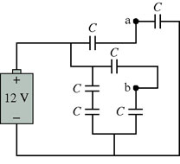.
a) What is the equivalent capacitance of these six capacitors?

b) What is the potential difference between points a and b?

2. The potential at the center of a 3.00-cm-diameter copper sphere is 900 , relative to at infinity. How much excess charge is on the sphere?

