I need assistance with below, please.

- Develop the strategic objectives for your business, Evening Elegance, in the format of a balanced scorecard (use below template). The strategic objectives are measures of attaining your vision and mission. As you develop them consider the vision, mission, and values for your business and the outcomes of your SWOTT analysis. Consider the following four quadrants of the balanced scorecard when developing your strategic objectives:

  - Shareholder Value or Financial Perspective, includes strategic objectives in areas such as:

    - Market share
    - Revenues and costs
    - Profitability
    - Competitive position

  - Customer Value Perspective, includes strategic objectives in areas such as:

    - Customer retention or turnover
    - Customer satisfaction
    - Customer value

  - Process or Internal Operations Perspective, includes strategic objectives in areas such as:

    - Measure of process performance
    - Productivity or productivity improvement
    - Operations metrics

  - Learning and Growth (Employee) Perspective, includes strategic objectives in areas such as:

- Employee satisfaction
- Employee turnover or retention
- Level of organizational capability
- Nature of organizational culture or climate
- Technological innovation

- Develop at least three strategic objectives for each of the following four balanced scorecard areas identified above (Financial, Customer, Process, Learning and Growth). Your objectives should be selected, in part, based on an evaluation of a number of potential alternatives to the issues and/or opportunities identified in the SWOTT Analysis paper and table you completed in Week Three. Base your solutions on a ranking of alternative solutions that includes an identification of potential risks and mitigation plans, and a stakeholder analysis that includes mitigation and contingency strategies. You should also incorporate the ethical implications of your solutions into your selection.

  - For each strategic objective, develop a metric and target using a balanced scorecard format. (For example, a strategic objective in the shareholder or Financial Perspective is to increase market share. A metric to actually measure this strategic objective of market share increase is, "The percentage of increase in market share." The target is the specific number to be achieved in a particular time period. The target for the metric of "Increase market share" could be "Increase market share by 2% for each of the next 3 years" of an increase of 2% per year for 3 years.)

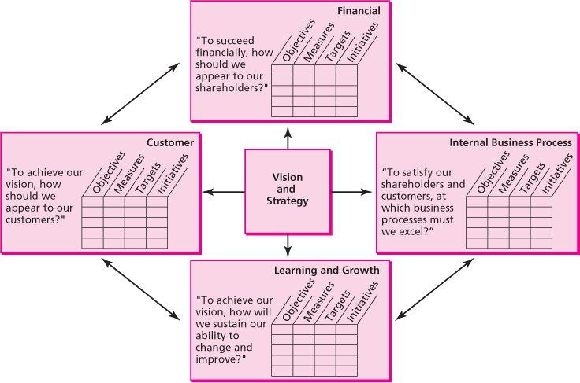

My Business is: A retail store called Evening Elegance

The idea is to introduce a custom made evening wear line where each garment has its own definition. You can have your garment copyrighted as it would be the first of its kind created and that’s a guarantee. Our brand name is Evening Elegance. Evening Elegance is a blend of old values and modern outlook that exists in congruity within our society. Our ideologies have undergone a paradigm shift and yet there is some innate quality within us that still binds us together regardless of our age, color or creed. Evening Elegance is a celebration of this bond that defines us. Through our brand, we intend to capture the mindset of today’s elegant young women who believe in unique self-image and feel strongly about one’s individuality.
- Write a 700- to 1,050-word summary, in your own word with no plagiarism or copying from websites that explains your critical thinking on how you derived your objectives from your vision, mission, values, and SWOTT analysis.

