1. Compute the Laplace transform of e^{-10t}cos(3)u(t).

2. Compute the z-transform of the discrete time signal defined by:
x[n] = δ[n] + 5δ[n - 1]

3. Compute the inverse Laplace transform of X(s) = | s+2  s²+7s+12

4. Determine if the signal given is linear, time-invariant, causal, and/or memoryless.
y(t) = [sin(6t)]x(t)

5. A continuous time signal x(t) has the Fourier transform | X(ω) | = | 1  jω+b
where b is a constant. Determine the Fourier transform for v(t) = x(5t - 4).

6. Compute the unit-pulse response h[n] for the discrete-time system
y[n + 2] -2y[n + 1] + y[n] = x[n] (for n= 0, 1, 2, 3)

7. Determine the inverse DTFT of X(Ω) = sin(Ω)cos(Ω).

8. Determine if the signal given is linear, time-invariant, causal, and/or memoryless.
y(t) = d^{x(t)}

9. Determine if x(n) = cos ( | πn  4 | )cos( | πn  4 | ) | is periodic;
if periodic, calculate the period.

10. Compute the DTFT of the discrete-time signal x[n] = (0.8)^{n}u[n].

11. Compute the impulse response h(t) for | dy(t)  dt | - | 3y(t) = x(t).

12. Compute the inverse Fourier transform for X(ω) = sin²3ω.

13. Determine if x(t) = cos(3t + | π  4 | )
is periodic; if periodic, calculate the period.

14. Determine if the linear time-invariant continuous-time system defined is stable, marginally stable, or unstable.
s - 1

s² + 4s + 5

15. For a discrete-time signal x[n] with the DTFT | X(Ω) | = | 1  e^{jΩ}+ b
where b is an arbitrary constant, compute the DTFT V(Ω) of v[n] = x[n - 5].

16. For the RC circuit shown in the figure, find the input/output differential equation.
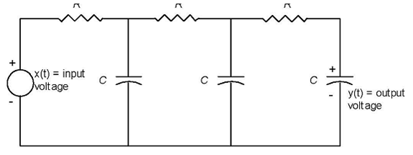

17. Solve the differential equation | dy(t)  dt | + | 2y(t) = x(t);
where x(t) = u(t), and y(0) = 4.

18. Solve the differential equation | d²y(t)  dt² | + | 3 | dy(t)  dt | +2y(t) = 0, y(0) = 1, y(0) = 0.

19. Compute the Fourier Transform for the convolution of sin(2t)*cos(2t) .

20. Use the Laplace Transform to compute the solution to the differential equation
defined by | dy  dt | + | 2y = u(t) where y(0) = 0.

