5.
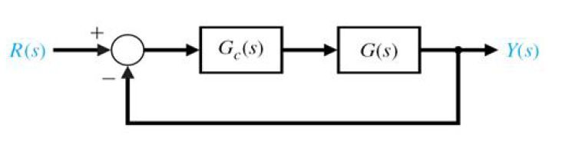
In the figure above, if
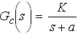 and 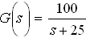
find the gain (K) of the compensator so that overall closed-loop response to a unit step input has a maximum overshoot of , and a 2% settling time of 0.1 sec.

7. For a unity feedback system, the plant or process is:
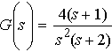
Find the steady state error when the input is:
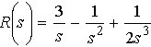

8. A system with unity feedback has the following process transfer function:
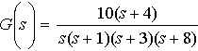
Determine the type and the steady-state error for a step input.

11. A single-loop negative feedback system has a loop transfer function:
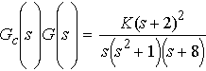
Determine the range of the gain K for which the system is stable using Routh-Hurwitz.

13. The closed-loop transfer of a given system is given by the following:
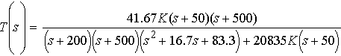
Determine the steady-state error when the K=10 for a step-input.

