Problem 28.49
The figure 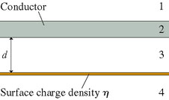shows an infinitely wide conductor parallel to and distance from an infinitely wide plane of charge with surface charge density , where .
Part A
What is the magnitude of the electric field in region 1?
ANSWER: | Answer not displayed

Part B
What is the direction of the electric field in region 1?
ANSWER: | Upward Downward The field is zero Answer not displayed

Part C
What is the magnitude of the electric field in region 2?
ANSWER: | Answer not displayed

Part D
What is the direction of the electric field in region 2?
ANSWER: | Upward Downward The field is zero Answer not displayed

Part E
What is the magnitude of the electric field in region 3?
ANSWER: | Answer not displayed

Part F
What is the direction of the electric field in region 3?
ANSWER: | Upward Downward The field is zero Answer not displayed

Part G
What is the magnitude of the electric field in region 4?
ANSWER: | Answer not displayed

Part H
What is the direction of the electric field in region 4?
ANSWER: | Upward Downward The field is zero Answer not displayed

