Problem 28.28
The figure 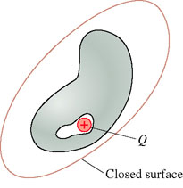shows a hollow cavity within a neutral conductor. A point charge is inside the cavity.
Part A
What is the net electric flux through the closed surface that surrounds the conductor?
ANSWER: | Answer not displayed

