Solve system of two equations with x and y (use any technique):
- 2x - y = 0
3x + 2y = 7
- x + 2y = 4
2x – y = -7
- 4x + y = 15
2x + 5y = 21
Assign x and y for unknown values, create system of two equations and find solution:
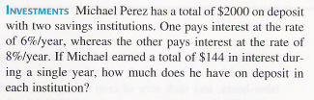
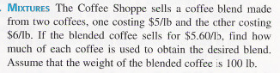
- Simple calculator costs $5 and scientific calculator costs $16.
The store sold 35 calculators and received $340.
How many of each calculator was sold?

