Exercise # 24.

In Exercises 21–32, use the figure to find the following
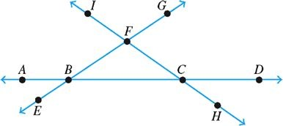

Exercise 9.3 # 16
In Exercises 15–18, determine (a) the area and (b) the circumference of the circle. Use the key on your calculator and round your answer to the nearest hundredth
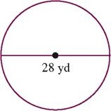

________________________________________________________________________________________________
Exercise page. 603 #6
In Exercises 1–6, use the figure shown to determine the following:

