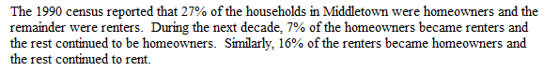
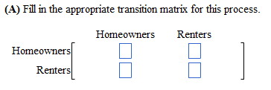
(B) What percentage of households were homeowners in 2000?
(C) What percentage of households will be homeowners in 2010?

