Price Earning Ratios
Find the mean, median and the mode for the data in the following table.
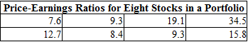

The means is approximately_____?
The median is approximately_____?
The mode is approximately_____?

