- Determine if the signal given is linear, time-invariant, causal, and/or memoryless. y[n+1] + y[n] = 2x[n+1] - x[n]

- For the series RLC circuit in the figure below find the input/output differential equation for y(t) = i(t).
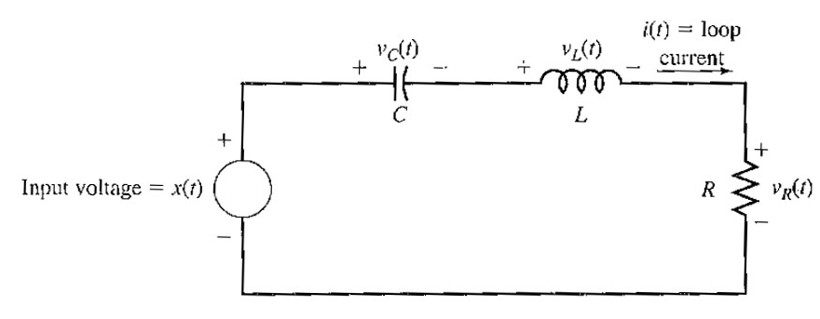

and y[n+2]-1.9y[n+1]+0.9425y[n]=0.01x[n] Bottom of Form

