Getting Off the Ground at Boeing
When the Boeing Corporation announced its intention to build a new plane, the project was an enormous undertaking. Research and development had already begun two and a half years earlier, and Boeing had already spent $873 million. Aggregate development cost, disregarding the time value of money, was expected to be between $4 billion and $5 billion. Production facilities and personnel training would require an additional investment of $2.0 billion, and they would need $1.7 billion in working capital when deliveries began in six years. The following table shows projected future cash flows for the project at the time of Boeing’s announcement. Boeing’s cost of capital was 18%.
CASH FLOW PROJECTIONS FOR THE BOEING PROJECT (DOLLAR AMOUNTS IN MILLIONS)
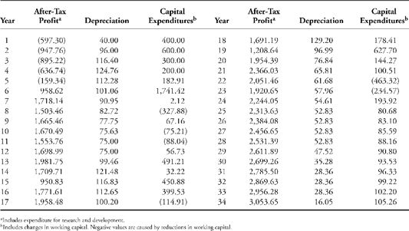
QUESTIONS
1. Calculate the NPV, IRR, and payback for the project.
2. On the basis of your analysis, do you think Boeing should have continued with this project? Explain your reasoning.

