Compute each of the ratios listed below for OutBack SportWear, using the information given in their balance sheet, income statement and statement of cash flow.
Assume the common stock has a current market value of $47.25.
Provide an analysis of the ratios.

LIQUIDITY RATIOS
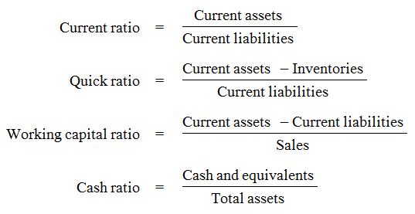
ASSET ACTIVITY RATIOS
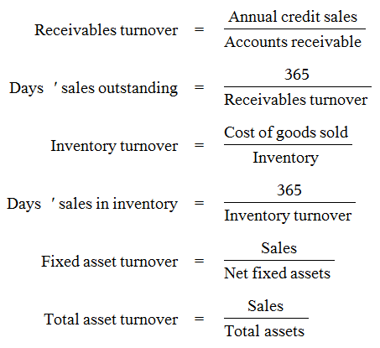
LEVERAGE RATIOS
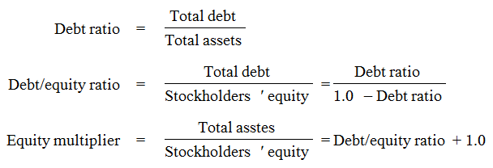
COVERAGE RATIOS
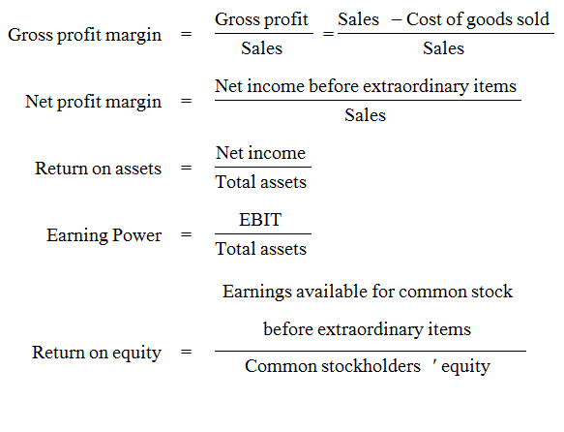
PROFITABILITY RATIOS
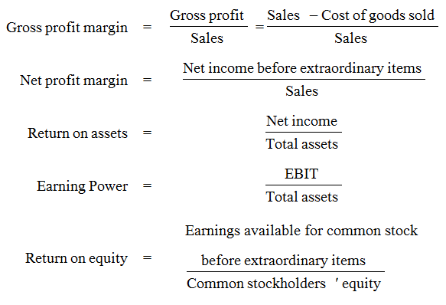
MARKET VALUE RATIOS
