Optical Illusions – finding dy/dx for different figures

In each graph below, an optical illusion is created by having lines intersect a family of curves. In each case, the lines appear to be curved. Find the value of dy/dx for the given values of x and y for each of the below. Please show your work so I can learn from this!! I don’t get optical illusions!
1) For Figure A below (the circles):
Circles: x² + y² = C²
x = 3, y = 4, and C = 5

2) For the hyperbolas (Figure B):
xy = C, x = 1, y = 4, C =4

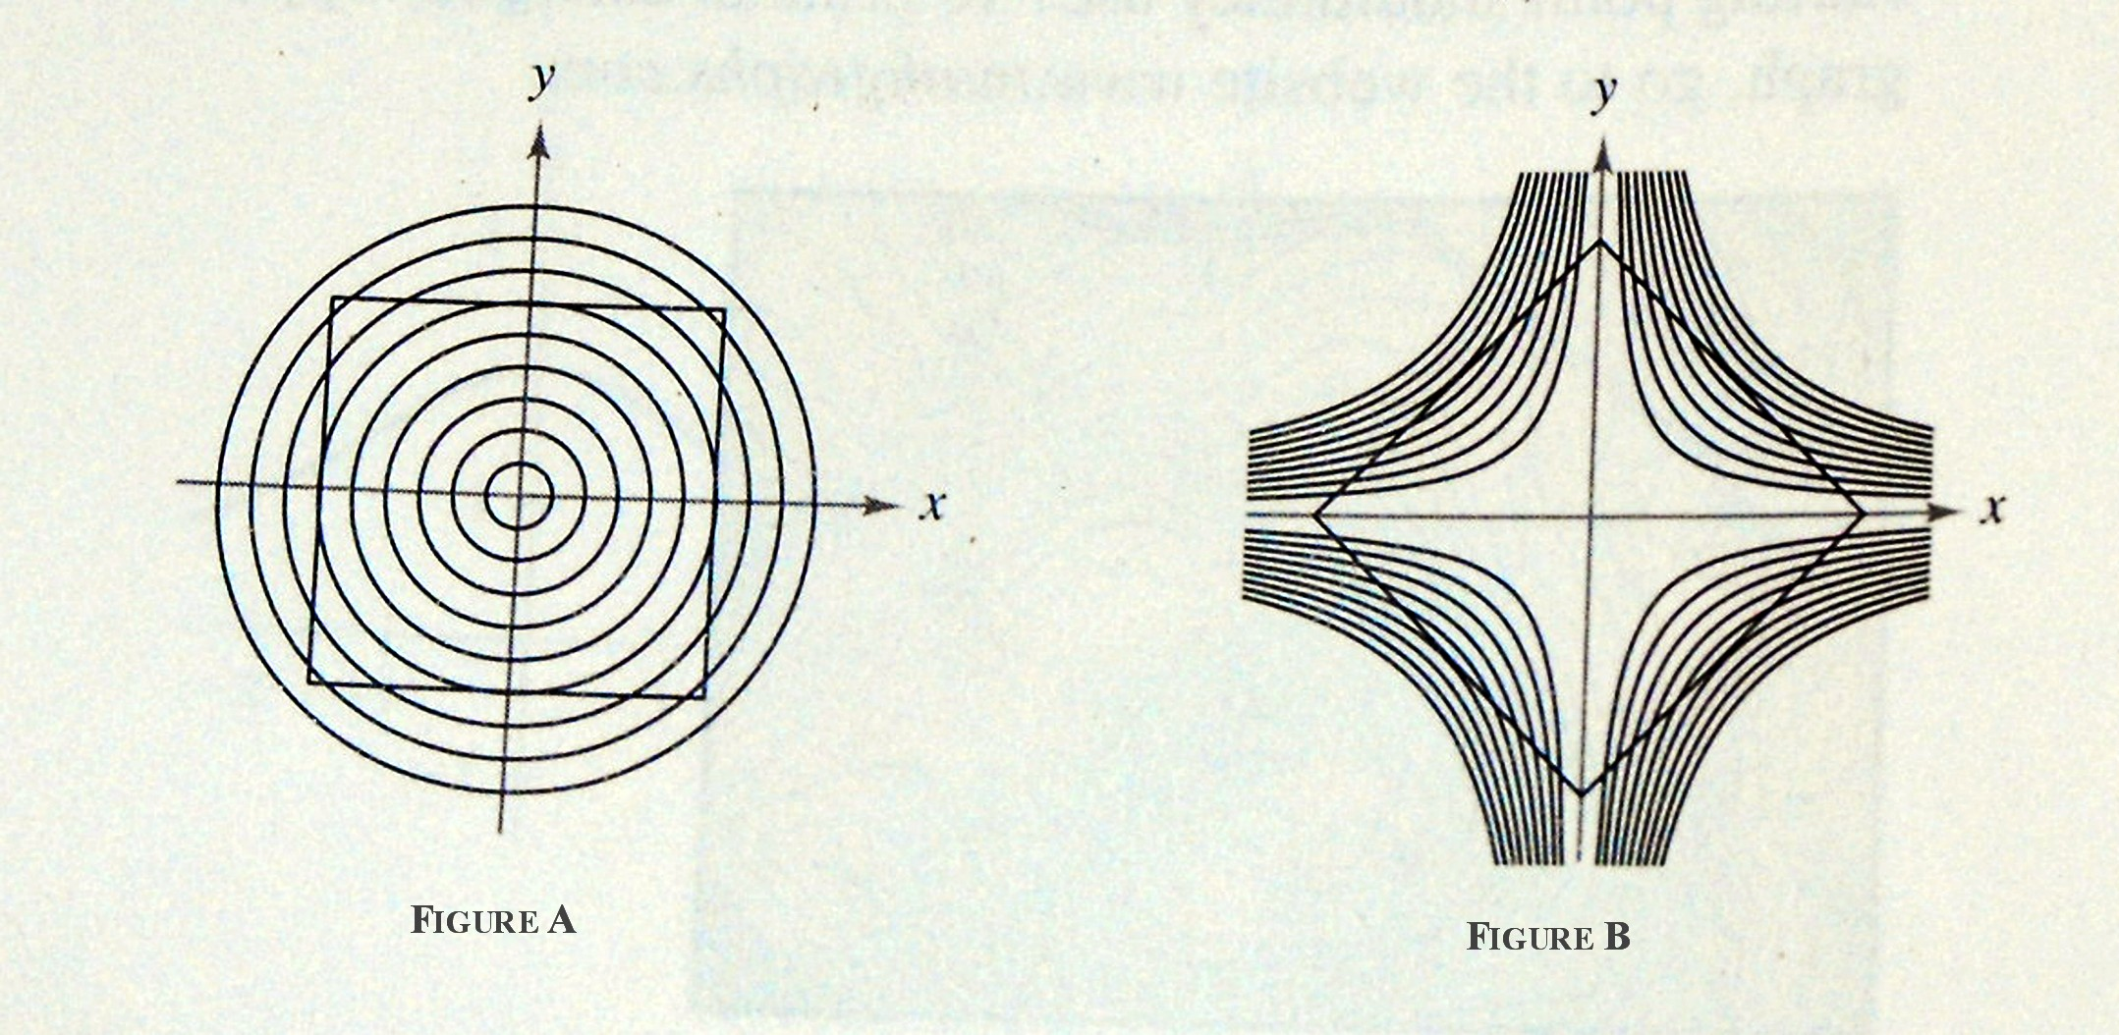
Keep scrolling….

3) For Figure C below:
Lines: ax = by
x = Square root of 3, y = 3
a = Square root of 3, b = 1

4) For Figure D below:
Cosine curves: y = C cos x
x = π/3, y = 1/3, C = 2/3



