BMQ # 345881

Cost Leadership Strategy
Cost leadership objectives facilitate low cost producers within industries. Numerous market segments are provided with emphasizing minimization of costs. Once an achieved price can be near the market average, then (in theory) a low cost manufacturer will be the most profitable. Cost leadership strategies are frequently connected to comprehensive industries which offer "ordinary" products with comparatively modest differentiation, which are absolutely satisfactory to the consumer target market. Sporadically, low cost leaders discount products to take advantage of sales, predominantly when the company has a considerable cost advantage over its competitors; in doing so, an organization can supplementary boost their market share (Wheelen & Hunger, 2007).
Specific Implementation Plans and Timelines:
Specific objectives and tactics recommended to Church & Dwight would be in calculating production expenditures, escalating its aptitude utilization, controlling its product distributions or material supplies, and reducing supplementary costs; as well as advertising and research and development. Economies of scale, mass production, innovative technologies, mass allocation, product designs, learning-curve remuneration, lower outlay in production, reduction of workforce, will additionally help Church & Dwight in the implementation of a cost leadership strategy to retain a low cost foundation (David, 2010).
Upper management will need to personally analyze cost efficiencies in all of Church & Dwight's processes. Church & Dwight will need to maintain a low cost base as its chief determinant of its cost leadership strategy. This can be very effective with Church & Dwight large market share. Competition with less significant market share might not profit as much as Church & Dwight, since mass distribution, mass production and economies of scale will not make an impression on such enterprises. Church & Dwight will fortify its positioning through advantages achieved via experience and scale in lower cost leadership strategies (Wheelen & Hunger, 2007).
Implementing cost leadership strategies would require Church & Dwight to give particular deliberation to its organizational formation, organizational controls, compensation guidelines, and execution of its cost leadership strategy. Each implementation tool and organizational arrangement must reinforce their strategy. Common resources needed when Church & Dwight implement their cost leadership strategy are access to resources, continued capital investments, development of manufacturing skills, labor management, ease of manufacturing, and an economical distribution system. Requirements for the implementation of Church & Dwight's cost leadership strategy would constitute frequent and tight control of detailed reports, structured responsibilities, and enticement based on the expectation of quantitative targets. Upper management would need control systems in place which would support implementation of the cost leadership strategy; including expenditure control systems, quantitative outlay objectives, supervision of employment, inventory management, raw materials and specifically a corporate philosophy of cost leadership (Barney & Hesterley, 2010).
The first step in the year one cost leadership strategy is for Church & Dwight's global proposal to develop Administrative, Marketing and Human Resource divisions. Personnel and facilities will have to expand in order to handle an increasing of workers, and a new market demand. The extended administrative allotment will center on maintaining a concise visualization during the process; in addition to providing management to every internal and external departments. The recently selected administrative staff will focus on growth and development, ensuring a smooth conversion. Policies will require ratification and implementation; within ethical and legal boundaries of Church & Dwight's global business (Open Learning World, 2010).
Newly established divisions will assure functionality and compliance into the transition of global markets. Resources, such as personnel and facilities, must be allocated in these departments; this would be initially expensive, however it would assure streamlined utilities. Measurements of achievement would aid in the expansion of departments. Failure would result in an amplified focus from management, to reach desired effects. Increasing crucial resources would aid in achieving a most advantageous success rate (Barney & Hesterley, 2010).
Projected Costs of Strategic Implementation:
Assembling precise information is the foundation of any ingress strategy. Essential sale projections must be incremented with comprehensive outlay statistics and fiscal data on assets. The information must be collected for the proposed strategy, for consideration. Financial data must be collected for the projected venture, as well as the estimated impact on existing operations. The amalgamation of financial records will result in an augmentation of financial information which would incorporate the overall net benefits of the future move for Church & Dwight's structure. Costs, asset requirements, and sales must be appraised over the development scope of the planned venture, characteristically 3-5 years for a typical company (David, 2010). In addition, comprehensive sensitivity analyses should be integrated. The analyses would consist of several assuming scenarios of globalized risks which could adversely influence the success or failure of the proposed venture. With each set of circumstances, financial data can be attuned. For example, with the implementation of the cost leadership strategy, Church & Dwight may want to embrace twenty percent devaluation within the host nation, shared with exchange control and intricacy in receipt of new supplies from overseas plants (Open Learning World, 2010).
Functional Areas Impacted:
1) Finance - Continued access to capital and capital investment.
2) Marketing - Promotion of new product within a global environment.
3) Management - Rewards for cost reductions, with incentives for meeting stringent quantitative target objectives and increasing quality.
4) Production - Rigid cost control processes: detailed and frequent control reports, with supervision of inventories, labor, distribution, raw materials, and other costs.
5) R&D - Development of engineering skills; product planned for ease in production.
6) Distribution - Establishment of logistics for a global product.
7) Managerial Leadership - Operating decisions are delegated to division management with full profit-and-loss accountability and responsibility for operations.
8) Human Resource Management - Expansion of workforce: staffing and training.
9) Information Systems - New software implementation for new product development.
10) Organizational and Corporate Culture - A cost leadership philosophy. (QuickMBA, 2010)
Projected Outcomes of Proposed Strategy:

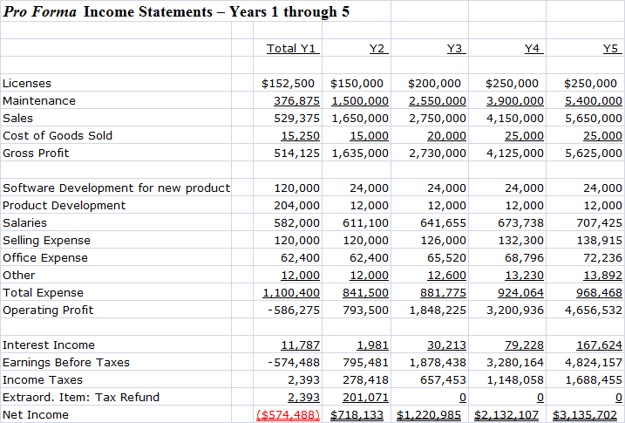

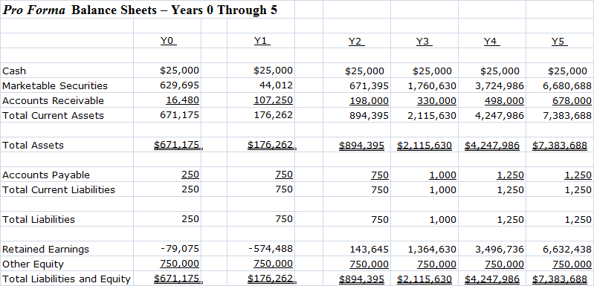

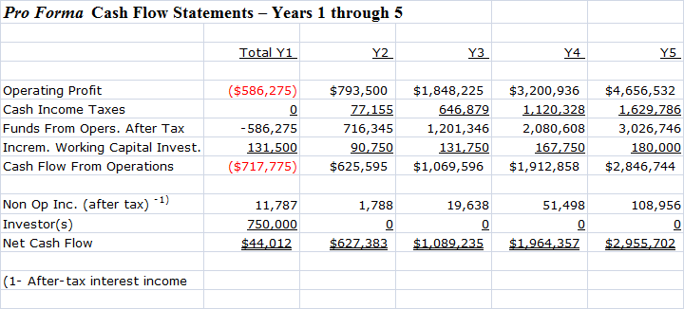

How will Progress be Monitored and Evaluated?
The progress will be monitored and evaluated through the use of milestones. Milestones are used in determining if objectives and goals have been realized through the utilization of mechanisms such as balance sheets, financial cash flow statements, income statements, inventories and working capital. All which measure quantitative data for sales, production, investment returns, profits, and cost of products sold. Mechanisms, for instance quality control checklists, surveys, and audits, will determine qualitative measures at five years. These analyses will verify how all recorded results will measure up to previous years (David, 2010).
Proactive Measures: Audits will be assessed at timeframe targets, in every stage in the implementation of the cost leadership strategy. Every audit mechanism will calculate every implementation step, the proportion completed, the resources exhausted, each come upon dilemma, every workaround utilized, as well as potential achievement dates to appraise if the plan was meeting current expectations (David, 2010).
Reactive Measures: Reactive measures would be monitored and evaluated though the use income statements, balance sheets, inventories, bills of lading, or supplementary inventory reports to measure quantitative data for profit, sales, ROI, and cost of goods sold. Inventory and production reports would gather and evaluate measures such as production capacity, cost per unit, costs per unit, and defects per units, labor costs, value and ease of use (David, 2010).
Human Resources, Finance, Research & Development, Manufacturing and Production, and Customer Service departments would all be responsible for monitoring, evaluating and reporting measures of achievement (QuickMBA, 2010).
Qualitative Measures: These would be costly and protracted methods utilized in collecting data through exhaustive interviews, observations, non-statistical data and focus groups. In addition insights, data and details from Church & Dwight's shareholders and participants would provide information regarding their personal opinions, experiences, and consumer behavior (David, 2010).
Quantitative Measures: These would be cost-effective processed utilized in collecting data via web-based, in-person, email and/or phone via the employment of questionnaires and/or surveys; obtainable database info, and statistical analyses. In addition, market research data, performance figures, and Church & Dwight's non-confidential consumer data and growth reports and would be utilized (David, 2010).

References
Barney, J. & Hesterley, W. (2010). Strategic Management and Competitive Advantage: Concepts and Cases. Upper Saddle River, NJ: Pearson Prentice-Hall.
David, Fred R. (2010). Strategic management: concepts and cases (13th ed). Upper Saddle River, NJ: Pearson Prentice-Hall.
Open Learning World (2010) Cost Leadership Strategies. Retrieved from http://www.openlearningworld.com/olw/courses/books/Business%20Strategies/Business %20Strategy/Cost-Leadership%20Strategy.html
QuickMBA (2010) Global Strategic Management. Retrieved from http://www.quickmba.com/strategy/global/
QuickMBA (2010) Strategic Management Planning. Retrieved from http://www.quickmba.com/strategy/strategic-planning/
Wheelen, T. & Hunger, J. (2007). Essentials of Strategic Management, 4th ed. Upper Saddle River, NJ: Pearson Prentice Hall.

(PLEASE MAKE SURE TO REFERENCE YOUR OWN TEXTBOOK AND CITE THE AUTHOR (S) WITHIN THE BODY OF THIS PAPER….)

