Problem 1

Company A purchases goods from its supplier on terms of 2/10, net 40. The effective annual cost to Company A if it chooses not to take advantage of the trade discount offered and stretches the accounts payable to 60 days is closest to: What is the EAR, effective annual rate?

Problem 2

Company A had sales of $980 million and a cost of goods sold of $560 million in 2006. A simplified balance sheet for the Company A appears below:
Company A Balance Sheet As of December 31, 2006 (millions of dollars)
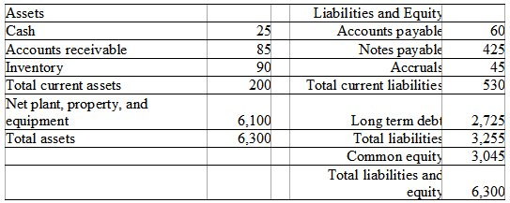
Company A cash conversion cycle is closest to: (Number of days)

Problem 3

Company A had sales of $980 million and a cost of goods sold of $560 million in 2006. A simplified balance sheet for the firm appears below:
Company A Balance Sheet As of December 31, 2006 (millions of dollars)
Company A Accounts Payable days is closest to: (Number of days)

