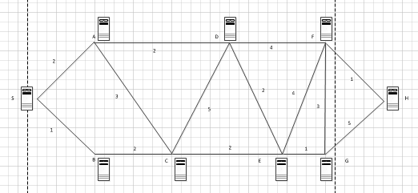

A special type of computer network exists to send messages quickly through a company. The message starts at S, and Finishes at H. Find the shortest path the message must take to get from S to H. [Note: for some reason , the distance between E, F did not copy well, that should be a 4.]

