1. Greenwich Company custom-produces specialty souvenir products. During 2009, the company completed the following transactions:
(a) Purchased $10,000 of raw materials, paying cash.
(b) Used direct materials in production as follows:

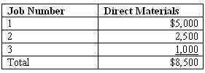

(c) Paid direct labor costs as follows:

(d) Paid cash for various actual factory overhead costs, $20,000.
(e) Applied factory overhead to production using a predetermined overhead rate of $1.50 per direct labor dollar.
(f) Completed Job 1.
(g) Job 1 was sold for $25,000 cash.
(h) Paid $500 for selling and administrative expenses.
(i) Any over-or-under applied manufacturing overhead is closed to cost of goods sold.

Required:
Compute the value of the WIP ending inventory.

2. Graceland Company uses process costing. The following information was available for October:

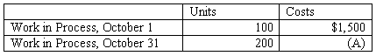

During October, 1,000 units were started, and costs incurred during the month were $18,500. Ending inventory was 50% complete. Based on the information given, (A) above would be what amount?

Selected accounts from Madison Company are provided below:

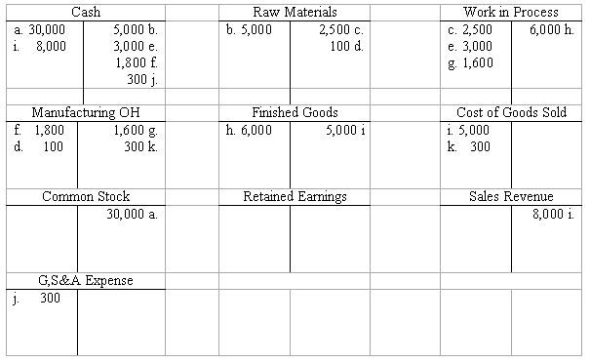
Required:
Determine the following:

