Evaluate.

((-1)² - 3)³ + 5 · (-5)

Simplify the following expression:

When converting from Fahrenheit degrees to Celsius degrees , a well known formula is used:
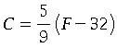. Solve for .

Simplify.
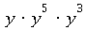

Simplify.
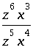

Simplify.
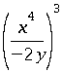
Write your answer without parentheses.

Rewrite the following without an exponent.
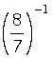

Simplify.
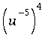
Write your answer without using negative exponents.

Simplify.
3w²w^{-2 ·} 4v⁻⁹v · 2x⁻⁸x⁸
Use only positive exponents in your answer.

Simplify.
Multiply.
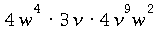
Simplify your answer as much as possible.
Multiply.
Simplify your answer.
Rewrite without parentheses and simplify.
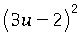

Multiply.
Simplify your answer.
Factor
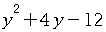 .
Factor.
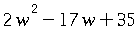
Factor.
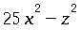
Factor:
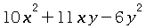

Factor:
.

Multiply. Write your answer in lowest terms.
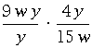

Simplify.
21n⁴/3x⁴y² / 7mn²/9x³y

Subtract. Write your answer in lowest terms.
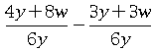

Add and simplify:
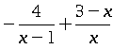

Simplify.
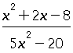

Solve for :
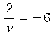 .
Simplify your answer as much as possible.

Solve for .
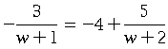

Solve the following proportion for .
Round your answer to the nearest tenth.

Milan runs miles in minutes. At the same rate, how many miles would he run in minutes?

Rewrite the following in simplified radical form.
Assume that all variables represent positive real numbers.

Simplify as much as possible.
Assume that all variables represent positive real numbers.

Simplify.
Assume that all variables represent positive real numbers.
Rationalize the denominator and simplify.

Solve for , where is a real number.

Solve for , where is a real number.

Find the value of .

Write the following in simplified radical form.

Solve for .

Solve the equation
for .

Solve 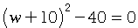 , where is a real number.
Simplify your answer as much as possible.

Use the quadratic formula to solve for .
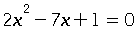

Write in simplified radical form by rationalizing the denominator.
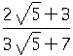

Simplify.
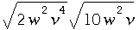
Assume that all variables represent positive real numbers.
Multiply.
Simplify your answer as much as possible.

Simplify as much as possible.
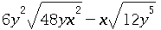
Assume that all variables represent positive real numbers.

Simplify.

Use the quadratic formula to solve for .
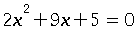

Solve for .
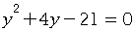

Simplify.
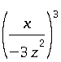
Write your answer without parentheses.

Rewrite the following without an exponent.
