16. Capital Structure. Examine the following book-value balance sheet for University Products, Inc. What is the capital structure of the firm on the basis of market values? The preferred stock currently sells for $15 per share and the common stock for $20 per share. There are 1 million common shares outstanding.

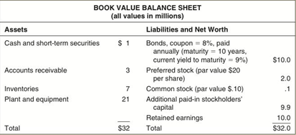
17. Calculating WACC. Turn back to University Products’s balance sheet from the previous prob- lem. If the preferred stock pays a dividend of $2 per share, the beta of the common stock is .8, the market risk premium is 10%, the risk-free rate is 6%, and the firm’s tax rate is 40%, what is University’s weighted-average cost of capital? (LO3)

