4. Listed below are the 27 Nationwide Insurance agents in the Toledo, Ohio, metropolitan
area. We would like to estimate the mean number of years employed with Nationwide.
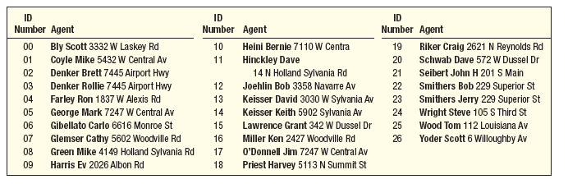a. We want to select a random sample of four agents. The random numbers are: 02, 59,
51, 25, 14, 29, 77, 69, and 18. Which dealers would be included in the sample?
b. Use the table of random numbers to select your own sample of four agents.
c. A sample is to consist of every seventh dealer. The number 04 is selected as the starting
point. Which agents will be included in the sample?

