1. Match correct sequence. Select A,B,C,D, or E

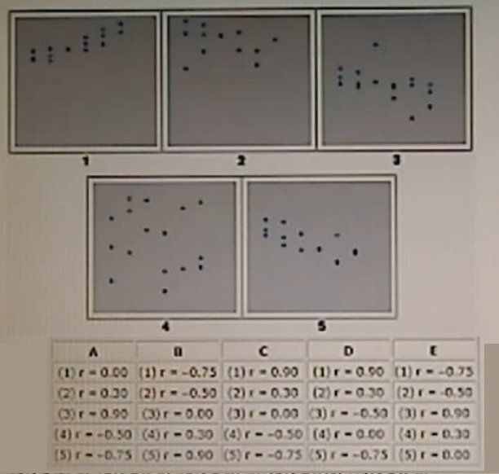

1. **Your company is bidding to supply towels to a government agency where the supplier with the lowest bid will win the contract. The cost of the contract is estimated to be $136,000, which the company increases by 15% to provide for profit.**

**You have estimated that the competitor’s bids are equally likely to be above or between $160,000. Furthermore you think that approximately 2/3rds of the bids will be between $150,000 and $170,000 and that the bids will be approximately normally distributed.**

**What is the probability of winning the contract?**

1. 15%
2. 26%
3. 50%
4. 64%
5. 85%
6. **Demand for a product is estimated to be normally distributed with a mean of 1200 units per month and a standard deviation of 100 per month. What monthly inventory level would satisfy demand at approximately a 95% service level?**
7. 900
8. 1050
9. 1200
10. 1350
11. 1600
12. **Demand for a product is known to be normally distributed with a mean of 750 units per week and a standard deviation of 80 units. What is the approximate standard deviation for annual sales (consider 52 weeks/year)?**
13. 80
14. 600
15. 4000
16. 7500
17. 37500