Problems and Exercises I
Read the following description of single-case research carefully and then answer the questions that follow.
Description:
A behavior therapist seeks to reduce the frequency of hitting behavior exhibited by a 6-year-old child in a classroom for emotionally disturbed children. The child frequently strikes other children and even the teacher. The therapist trains one of the teacher's aides to reward the child with small candy reinforcers when the child has not struck anyone for a period of 5 minutes. The experiment is conducted during two 1-hour sessions each weekday for a period of 4 weeks. An ABAB design is used, each week comprising a different stage. The results of this behavioral intervention are shown below:
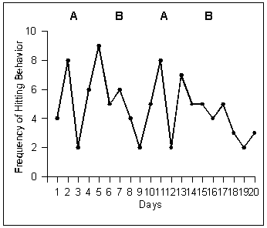

- Does visual inspection of the data obtained in this hypothetical study provide evidence for the effectiveness of the treatment? Why or why not?

- Provide two suggestions for improving the quality of the evidence for the effectiveness of the treatment in this situation.

