- Factor
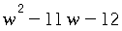

- Factor.
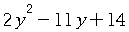

- Factor completely:
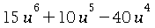 .

- Factor
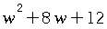 .

- Factor.
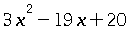

- Factor completely:
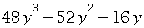 .

- Factor the quadratic expression
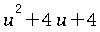.

- Factor.
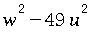

- Factor completely:
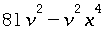 .

- Factor completely:
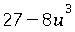 .

- Factor the quadratic expression
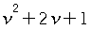.

- Factor.
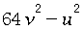

- Factor completely:
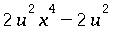 .

- Factor completely:
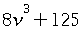 .

- Factor:
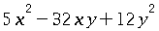

- Find the greatest common factor of the two expressions
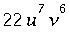and 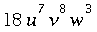.
Simplify as much as possible.

- Find the least common multiple of the two expressions
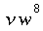and 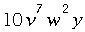.
Simplify as much as possible.

- Factor:
.

- Factor
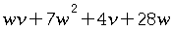.

- Factor:
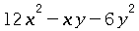

- Factor:
.

- Factor


