- From the graph below, state the coordinates of the point at which the two lines intersect

(Note to my BrainMass pal, if you are not able to read the numbers, they are )

Down: 7, 6, 5, 4, 3, 2, 1, 0

Across the numbers are – 6 -4 -2 -1 0 2, 4, 6,

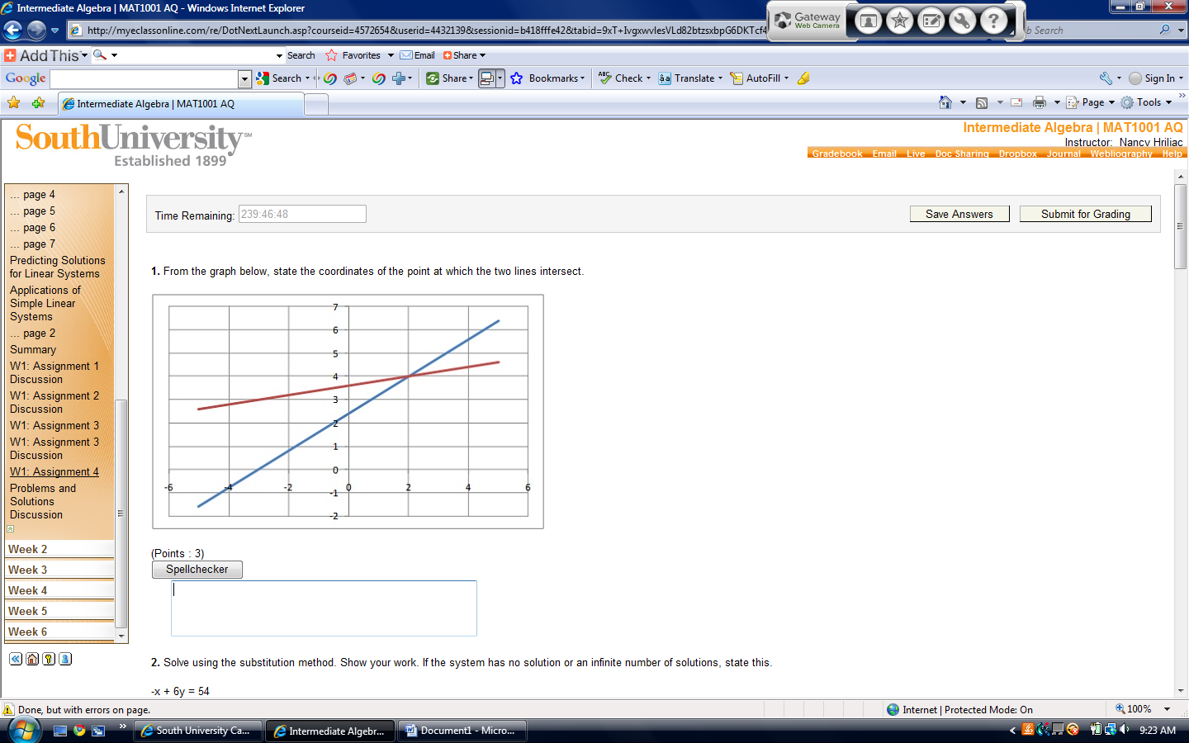

2. Solve using the substitution method. Show your work. If the system has no solution or an infinite number of solutions, state this.
-x + 6y = 54
3x + y = 9

3. Solve using the elimination method. Show your work. If the system has no solution or an infinite number of solutions, state this.
8x + 10y = -34
16x – 5y = -43

4. Solve using the elimination method. Show your work. If the system has no solution or an infinite number of solutions, state this.
-8x – 2y = -28
-3x + 5y = 47

5. Solve using the elimination method. Show your work. If the system has no solution or an infinite number of solutions, state this.
9x + 6y = 60
-27x – 18y = -180

6. Select the set of equations that represents the following situation: The cost of eight CDs and fifteen DVDs is $186.31; and the cost of nine DVDs and thirteen CDs is $167.09. How much do a CD and a DVD cost?
(Points : 3)
8x · 15y = 186.31; 9x · 13y = 167.09
8x + 15y = 186.31; 13x + 9y = 167.09
8x + 15y = 186.31; 9x + 13y = 167.09
8x · 15y = 186.31; 13x · 9y = 167.09

7. Select the set of equations that represents the following situation: Mary invested one amount at 9% simple interest, and a second amount at 6% interest, earning $18.12 in one year. If she had switched the amounts, she would have earned $17.88. What were the two amounts?
0.09x + 0.06y = 17.88; 0.09x + 0.06y = 18.12
0.09x + 0.06y = 18.12; 0.09y + 0.06x = 17.88
9x + 6y = 18.12; 9y + 6x = 17.88
9x + 6y = 17.88; 9x + 6y = 18.12

8. To buy both a new car and a new house, Tina sought two loans totalling $44,980. The simple interest rate on the first loan was 1.8%, while the simple interest rate on the second loan was 1.2%. At the end of the first year, Tina paid a combined interest payment of $679.64. What were the amounts of the two loans?

9. A dehydrated patient needs a 6.8% saline IV. Unfortunately, the hospital only has bags of 4% and 7% saline solutions. How many liters of each of these solutions should be mixed together to yield 3 liters of the desired concentration?

