- Evaluate.
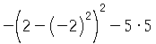

- Simplify the following expression:
.

- Solve for .
Simplify your answer as much as possible.

- Solve the inequality for .
Simplify your answer as much as possible.

- On Wednesday, a local hamburger shop sold a combined total of hamburgers and cheeseburgers. The number of cheeseburgers sold was two times the number of hamburgers sold. How many hamburgers were sold on Wednesday?

- Graph the line.

- Find the slope of the line graphed below.

(7, 3) AND (4, -6)

- Find the values of and that solve the following system of equations:
.

- Simplify.
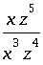

- Simplify.
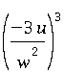
Write your answer without parentheses.

- Rewrite the following without an exponent.
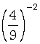

- Rewrite the following without an exponent.
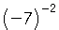

- Simplify.
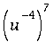
Write your answer without using negative exponents.

- Write in scientific notation.

- Calculate.
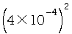
Write your answer in scientific notation.

- Simplify.
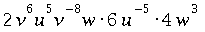
Use only positive exponents in your answer.

- Simplify.

(-3u^2-u) + (6u^2+3u+5) - (-4u^2+3u-3)

18.Multiply.
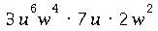
Simplify your answer as much as possible.

- Multiply.
Simplify your answer.

- Rewrite without parentheses and simplify.
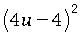

- Multiply.
Simplify your answer.

