(a)
Given two sequences x and y as shown below
Determine the minimum number of edit operations (substitution, and indels) required to transform one into another
________________________________________________________________________
(b)
Determine the Hamming distance between the strings: CENTURY and SANCTUARY
Determine the Levenshtein distance between the strings: BIO-INFORMATICS and TRI-TELEMATICS
_____________________________________________________________________

Binary representation of a DNA sequence: Concept
Sometimes DNA sequence analysis can be done by converting the sequence into binary format. Foe example, suppose the following dibit representation is pursued: A ⇒ (11); C ⇒ (01); G ⇒ (10); T ⇒ (00). The a sequence ACCTGCA, for example can be written as: 11 01 01 00 10 01 11

(c)
By constructing binary format of the pair of sequences x and y given below determine the Hamming distance between them.
(Hint: For binary strings a and b, the Hamming distance is equal to the number of ones resulting in a XOR b operation).

(d)
Given a template sequence: CCCAAGGGGTTCCAATG. Identify the underlying
mutations and derivatives namely, point-mutations, deletions, inversions, transportations, duplications, insertions in the following set of strings that resemble the template:
CCCAAGGGGTTTCAATG
CCCAAGGGGTTTCxxxx
CCGGAACGGTTTC
TTTCCCGGAACGG
TTTCCCGGGGAAGG
TTTCCCGGTTAACTTTGG
TTTCCCGGTTAACTTGG
How will you designate the following sequence in relation to the template?
AAAGGCCAATTGAAACC
(e)
Transition mutations are more common than transversions mutations.
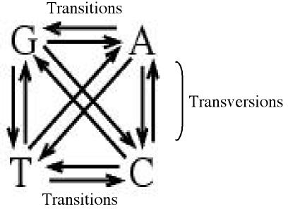

Construct a matrix to illustrate such characteristics of the mutations.Assume proportionate percentage to depict each type of mutation

 | A | T | G | C
A
T
G
C

x: T A G C T A T C G G G A A C T G
y G C T C A C G G T T G G G A C T

