- Calculate the feedback fraction in the figure.
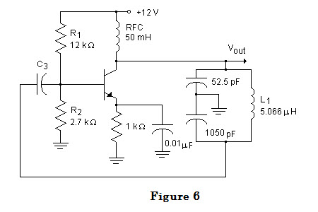
A) 20
B) 0.05
C) 0.5
D) 5
2.) For the CC amplifier shown in the figure, solve for A:
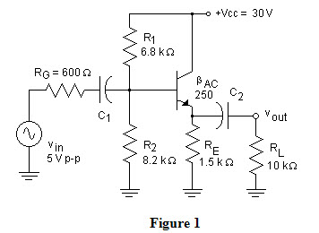
A) 0.566
B) 0.998
C) 2.40
D) 570

- For the circuit shown in the figure, solve for the A_{V}:
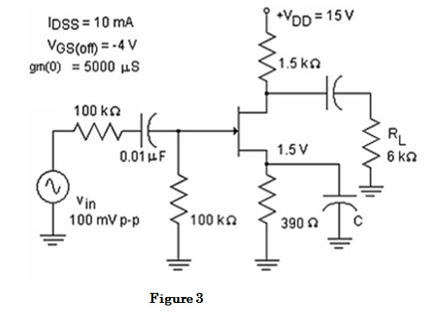
A) 7.5
B) 4.0
C) 3.75
D) 15.4

4.) For the regulator shown in the figure, let V_{BE} = 0.7 V and determine V_{out(max)}.
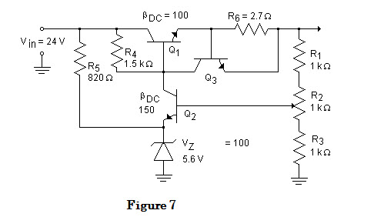
A) 18.9V
B) 9.45V
C) 12.6V
D) 10.4V

5.) For the regulator shown in the figure, let 0.7 V and determine the shorted load current, I_{SL}.
A) 230uA
B) 700uA
C) 259mA
D) 853uA
6.) In the figure, the transistors are identical with β_{dc} = 300. Use the second approximation of a diode to determine Z_{in}.
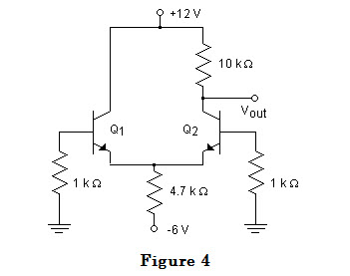

A) 44.3Ω
B) 13.3kΩ
C) 4.7kΩ
D) 26.6kΩ

7.) In the figure, the transistors are identical with β_{dc} = 300. Use the second approximation of a diode to determine V_{B}.
A) 0V
B) 0.7V
C) 1.4V
D) -6V

8.) An OP Amp has a slew rate of .5V/us. What is the highest frequency you can amplify without slew rate distortion if you desire a peak output of 6 volts?
A) .01326 Hz
B) 13.26 KHz
C) 10 KHz
D) 1 Mhz

