This question is about how the properties of particles may be found from their constituent parts, and how these relate to the forces between them.
1(a)
What are the electric charges of the baryon and antibaryon formed from thefollowing combination of quarks and antiquarks?
Choose the appropriate electric charge onto each baryon or antibaryon.

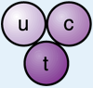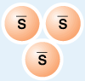

Choice of electric charges:
+3e +2e +1e 0 -1e -2e -3e

Fill in the blanks with phrases in bold below to complete the following sentence:
The electric force between the baryon and the antibaryon is ___________and its strength is ______________ than the strength of the electric force between two electrons at the same separation.
repulsive
attractive
the same
2 times stronger
2 times weaker
3 times stronger
3 times weaker
4 times stronger
4 times weaker

