- Find the mean of the distribution shown.
x | 1 | 2
P(x) | 0.31 | 0.69

A) 0.96 B) 1.42 C) 1.18 D) 1.69

- For a normal distribution with mean 5 and standard deviation 6, the value 11 has a z value of
A) –1 B) 1 C) 2 D) 3

- If the standard deviation of a probability distribution is 6.25, the variance is 2.30
True/False

- A stem and leaf plot is useful for keeping more precision than a grouped frequency distribution.
True/False

5. | What kind of relationship does the scatter plot show between x and y?  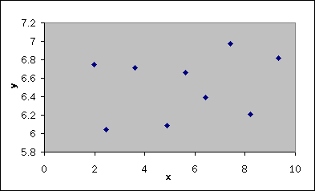
 | A) | A positive linear relationship | C) | No linear relationship
 | B) | A negative linear relationship | D) | This is not a scatter plot
- A researcher conducted a study to record the colors of students' eyes. The appropriate measure(s) of central tendency is (are):
A) The mode B) The median C) The mean D) Both the mode and the median

