RUNNING HEAD: Competitive Advantage Analysis

Competitive Advantage Analysis

When shopping, it is likely that there would be more than one selection of the product being purchased. Consumers typically make purchasing decisions based on key attributes that the product possesses. These attributes will be discussed with examples relating to the AdSim simulation. In the simulation, the Genie is competing against the Kanon. The identification of the emotional and rational attributes that may sway a consumer’s purchasing decision will be discussed and displayed graphically. The unique competitive advantages of the Genie will also be described and how the benefits can support the Genie’s success.
Cameras have many attributes that can sway a consumer’s decision on whether or not to buy it. Some of those attributes are functional to include the quality of the lens, the amount of megapixels, and the intensity of the zoom. These functional attributes are extremely important to the consumer and play a large role in the consumer’s decision making process. The cameras with the higher megapixel number take pictures with better image quality. However, the higher the number, the higher the price, cameras with a higher megapixel count, typically have a higher sale price. The zoom feature of a camera allows for clear pictures taken from a longer distance away. The greater the zoom capabilities, the better performing the camera is and the higher the price. According to Creech, 2010, megapixel, price and size count for the three most important functional attributes that a new consumer looks for when shopping for a new camera (Creech, 2010). Each one of these attributes can affect the price and quality of the digital camera.
There are numerous emotional attributes that consumers look for in a camera that will play a role in the decision making process. A cameras size and weight are important to today’s mobile consumer. For some, a camera is expected to fit into a small purse or pocket, for others it is more important to be comfortable to hold, which may require a larger size. Many consumers consider their camera an accessory to their style and wardrobe. Many consumers want a camera that is available in different colors that may suit their individual personalities and style. Market research from AdSim provides important data that correlates to these types of attributes and is displayed in Graph 1, below (University of Phoenix, 2010). The market research survey collected data based on a six-point Likert scale. The average responses to the Feature Preference question in the survey were reported. This information helps the marketer make better decisions for a more effective marketing strategy. The graph suggests new customers prefer the simplicity feature of a camera and existing customers prefer picture quality.
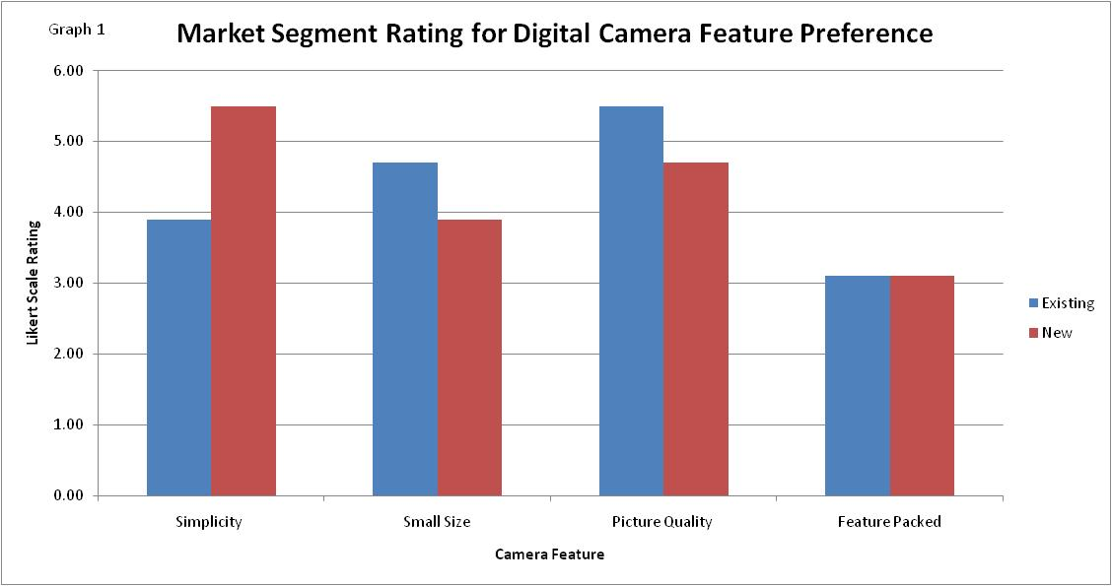
However, other consumers are more concerned with a certain brand. If the consumer has had a positive experience with a certain brand of camera, then the consumer will assume that purchasing that brands latest model will continue that positive experience. National name brands come with a certain status attached to them. The image is important to some people who assume brands are associated with status and that just because a certain name is on the product, it has to be good.
There are many factors that play a role in the decision making process of a consumer. Some are more easily identified; others are more personal and harder to figure. Regardless of the factors, it is important to listen to the consumer to determine what they look for in a product. Although not everyone can be pleased, getting as many opinions as possible will create a product that will appeal to a wide range of potential customers.
The digital camera, Genie, possesses competitive capabilities yielding some advantages against its competition, Kanon by Duncan, Inc. because of its distribution, advertisement strategies, and marketing strategies. The Genie may cost more at this time by only a few dollars, but the product is supported by a consumer electronics corporation, where the Kanon is provided by a Computer Company. Genie’s provider, being a consumer electronics corporation, seems to have an advantage over Duncan, Inc. because the product line that the corporation currently carries includes household electronics. This may include items like DVDs and VCRs as well as microwaves, vacuums, and even toaster ovens, to name a few, (Urbanatomy.com, 2010). These items are commonly found in just about any household. As some studies show, the digital camera has also become a common household item (BNET CBS Business Network, 2010). Digital cameras are becoming so common that in some communities each member of a family is likely to have his or her own digital camera. This helps the digital camera market because as families form and grow, the need for digital cameras becomes greater.
According to market research data purchased in the AdSim program, Kanon and Genie had practically an equal market share for digital cameras (University of Phoenix, 2010). The focus for the marketing strategies was to first identify strategies that target both the existing customer along with an emphasis on the new customers. Genie can do this easily through its distribution, but that alone is not going to allow for the product to survive let alone compete strategically against its competitor. As demonstrated in Graph 2, the target analysis identifies the target market and the level of expertise of the product needs, which offers a means for obtaining more effective marketing strategies. The information was collected from a Market Survey of Customer Needs. The information gauges where the emphasis should be placed toward the type of consumer, and in this case toward recreational for existing customers and family to target new customers. At the beginning of the simulation, a suggestion was stated that focusing on existing customers would help bring in new customers. One strategy push can support that once the existing cliental is established; a greater emphasis on new customers can be accentuated.
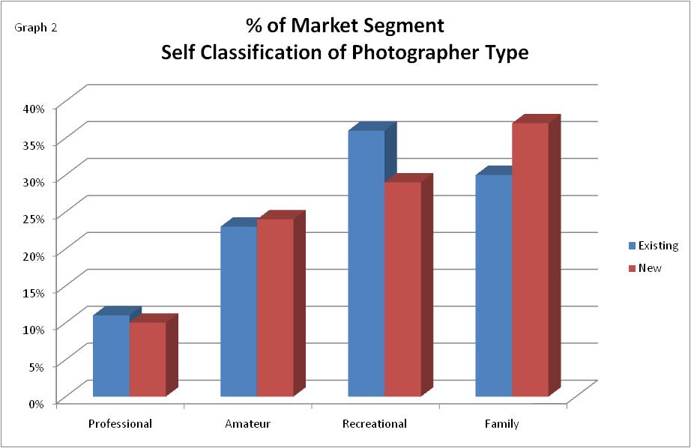
With the information suggesting ‘Family’, the advertising allocations can be designed more advantageously. Most families that would purchase a digital camera would probably have a television – perhaps in each room – and the viewing times can be assumed at prime-time. In addition to the advertising allocation, the age brackets and type of media that has traditionally attracted family and recreational type photographers can help increase the CPM. The CPM is the dollar cost of reaching 1,000 members of the media vehicle’s audience (Clow & Baak, 2007, p. 237). Clow and Baak continue describing the calculation by stating it includes taking into account the cost of the media, the amount of audience reached and a multiplication factor of one thousand (Clow & Baak, 2007, p. 237). The CPM is advantageous to the Genie if the right information is gather and interpreted accurately. Knowing that the product may do well when purchased by families, the chances are that the shopping family will recognize a product offered by a consumer electronics corporation before seeing it advertised by a computer corporation. If the cost of advertising is maximized to target a sufficient amount of new and existing customers, then the sales revenue will reflect an increase in sales volume and a greater market share. Gauging the cost of advertising, the media selections, and reaching the product’s target markets at a level with budget can yield a successful marketing strategy.
Market research data was used to interpret emotional preferences that help guide the market strategies and promote the product effectively. The unique advantages of the Genie compared to the Kanon in the AdSim simulation were discussed. Graphical displays of the data collected from market research demonstrate how the marketing promotional strategies help the Genie gain market share and meet and exceed the designated sales targets. The identification of the attributes and interpretation of how the attributes relate to the competition show a comprehensive view on the importance of market research and careful strategic planning for a successful marketing plan.

References
BNET CBS Business Network. (2010). Technology Industry. Retrieved from
http://findarticles.com/p/articles/mi_m3311/is_n9_v32/ai_19934654/
Clow, K., & Baack, D. (2007). Integrated Advertising, Promotion and Marketing
Communication.
Creech, H. (2010). Digital Camera Buyer's Guide. Epinions.com. Retrieved from
http://www0.epinions.com/buyers_guide/Digital_Cameras_buyers_guide_p1.html
University of Phoenix. (2010). Smartsims: Business Simulation and Strategy Games [Computer
Software]. Retrieved from University of Phoenix, Simulation, MKT498 - Integrated
Marketing Strategies website.
Urbanatomy.com . (2010). Family Guide. Retrieved from
http://shanghai.urbanatomy.com/index.php/city-guides-/family-guide/1681-household-
electronics-and-appliances

