You are given the following set of data:
 | Historical Rates of Return
Year |  | NYSE |  | Stock Y
1 |  | 4.0 | % | 2.5 | %
2 |  | 14.3 |  | 19.7
3 |  | 19.0 |  | 12.0
4 |  | - 14.7 |  | - 10.0
5 |  | - 26.5 |  | - 16.3
6 |  | 37.2 |  | 33.9
7 |  | 23.8 |  | 5.8
8 |  | - 7.2 |  | 2.1
9 |  | 6.6 |  | 14.2
10 |  | 20.5 |  | 23.5
11 |  | 30.6 |  | 20.0
 | Mean = | 9.8 | % | 9.8 | %
 | = | 19.6 | % | 14.8 | %
- Construct a scatter diagram showing the relationship between returns on Stock Y and the market. Use a spreadsheet or a calculator with a linear regression function to estimate beta.
Select the correct graph.
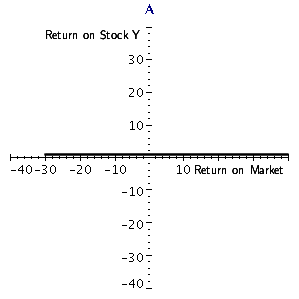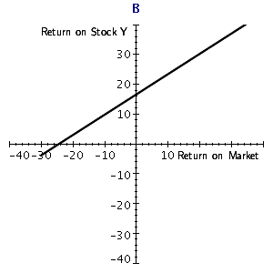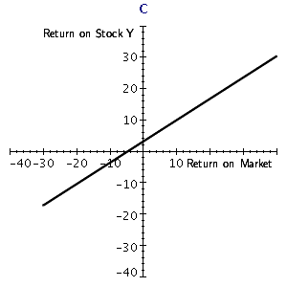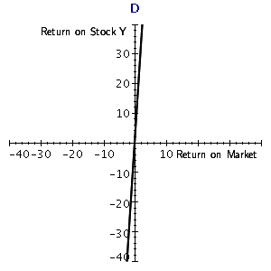
The correct graph is .
- Give a verbal interpretation of what the regression line and the beta coefficient show about Stock Y's volatility and relative risk as compared with those of other stocks. Round your answers to the nearest whole.
Stock Y is about percent as volatile as the market; thus, its relative risk is about percent of that of an average firm.
- Suppose the regression line were exactly as shown by your graph from part b but the scatter of points were more spread out.
  - How would this affect the firm's risk if the stock is held in a one-asset portfolio if the CAPM holds exactly?
Total risk .
  - How would this affect the actual risk premium on the stock if the CAPM holds exactly?
The risk premium under the CAPM .

- Suppose the regression line were downward sloping and the beta coefficient were negative.
  - What would this imply about Stock Y's relative risk?
Stock Y's relative risk .
  - What would this imply about Stock Y's correlation with the market?
Stock Y's correlation with the market .
  - What would this imply about Stock Y's probable risk premium?
Stock Y's probable risk premium .

