- If beta in the figure equals 150, what is the critical frequency of the input coupling circuit?
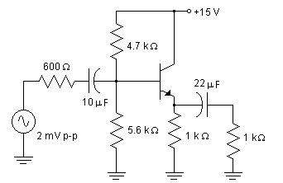
A) 3.35Hz
B) 75kHz
C) 26.54Hz
D) 5.8Hz

2.
If beta in the figure equals 200, what is the critical frequency of the output coupling circuit?
A) 14.48Hz
B) 7.24kHz
C) 3.62Hz
D) 7.24Hz

3. In the figure, the transistors are identical with β_{dc} = 200. Use the second approximation of a diode, and assume the bases are driven by low-impedance sources to find V_{out}.
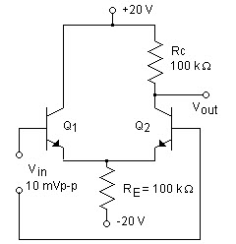
A) 10.00V
B) –20.00V
C) 9.65V
D) 10.35V

4. In the figure, the transistors are identical with β_{dc} = 200. Use the second approximation of a diode, and assume the bases are driven by low-impedance sources to find Z_{in}.
A) 259.0kΩ
B) 103.6kΩ
C) 200.0kΩ
D) 51.8kΩ

5.
In the figure, the transistors are identical with β_{dc} = 300. Use the second approximation of a diode to determine Z_{in}.
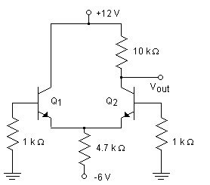
A) 44.3Ω
B) 13.3kΩ
C) 4.7kΩ
D) 26.6kΩ

6.
In the figure, the transistors are identical with β_{dc} = 300. Use the second approximation of a diode to determine V_{B}.
A) 0V
B) 0.7V
C) 1.4V
D) –6V

7. In the figure, the transistors are identical with β_{dc} = 300. Use the second approximation of a diode to determine V_{out}.
A) 5.2V
B) 0.7V
C) 10.4V
D) 6.4V

8.
In the collector circuit of the figure, C represents the combined capacitance of Cc’ and the stray capacitance. Calculate the critical frequency of the collector-bypass circuit.
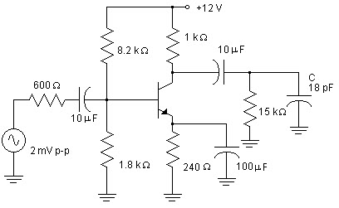
A) 589kHz
B) 9.43MHz
C) 1Hz
D) 16.9Hz

9.
In the figure shown above, the transistors are identical with β_{dc} = 200. When the common-mode input is 5 mV_{p-p}, determine V_{out}.
A) 1.93mVp-p
B) 2.50 mVp-p
C) 0.48 mVp-p
D) 10.35 mVp-p

10.
What is the critical frequency of the output coupling circuit in Figure 1?
A) 589kHz
B) 4.82MHz
C) 1Hz
D) 15.92Hz

