Appendix A
Figure 1

Summary Period End June 30, 2010
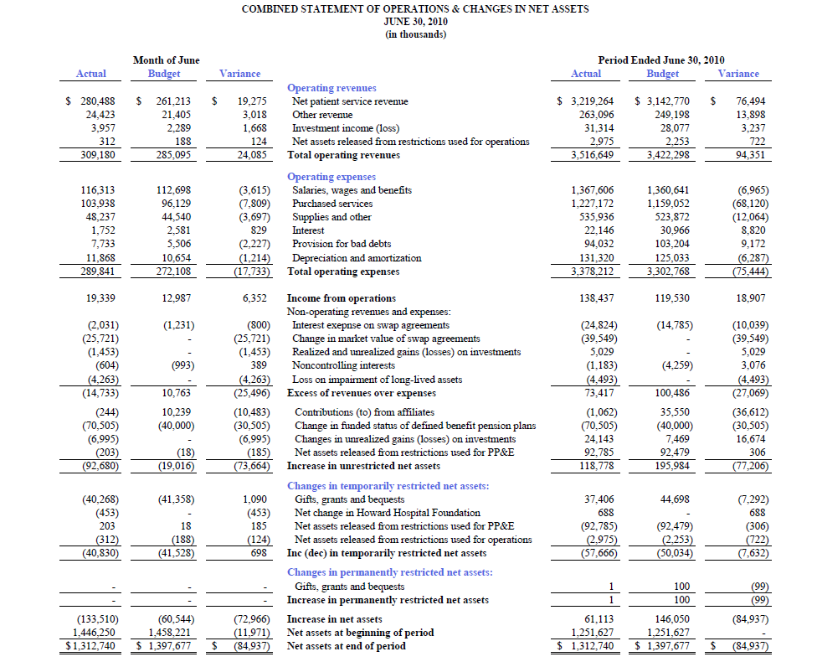

Appendix B
Figure 2

Statement of Operations June 30, 2010
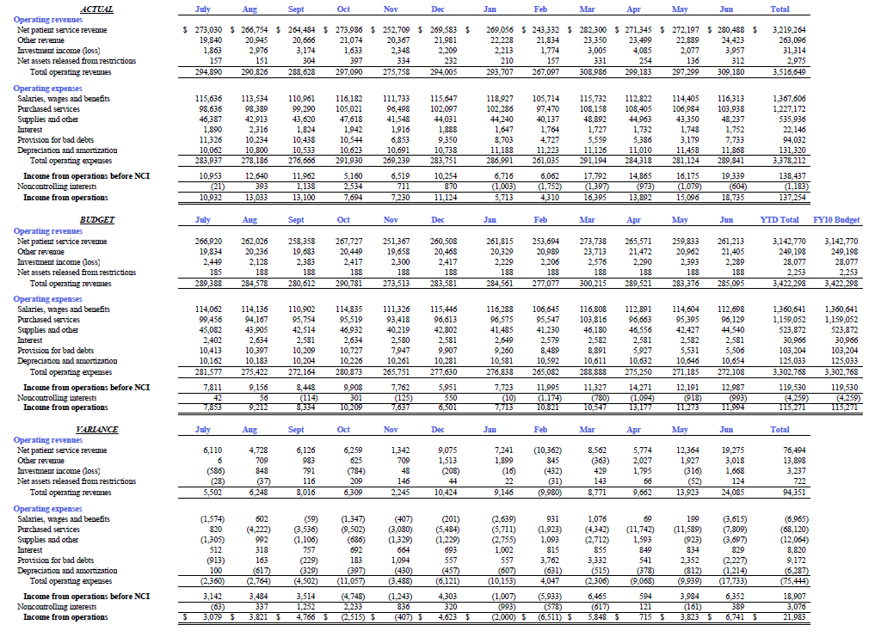

Appendix C
Figure 3

Balance Sheet
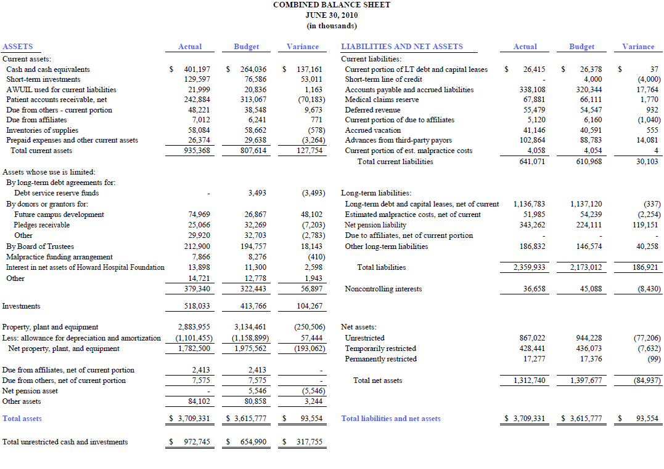

Appendix D

Figure 4

Statement of Cash Flows

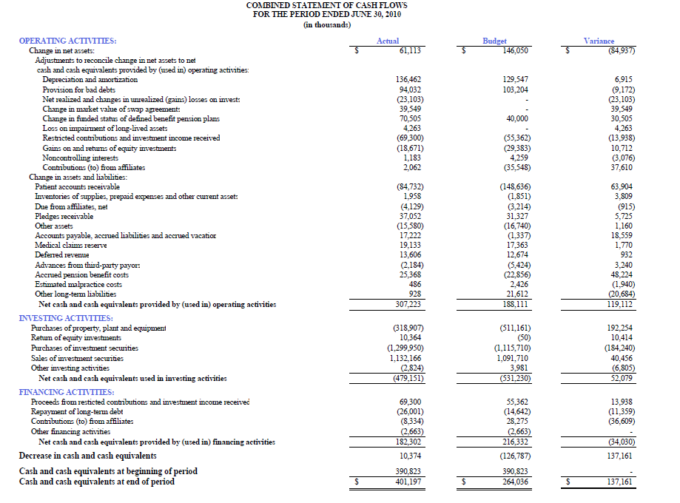

Appendix E

