Appendix A
Figure 1

Summary Period End July 31, 2010
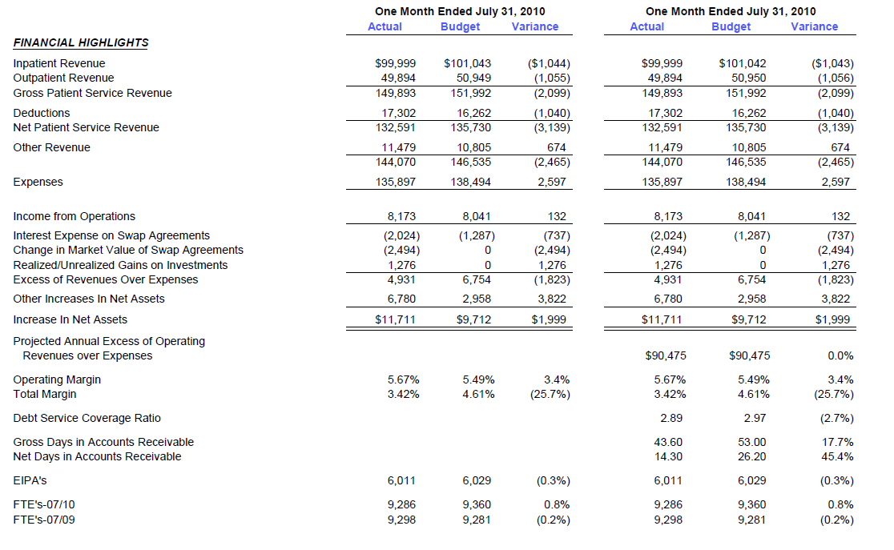

Appendix B
Figure 2

Statement of Operations

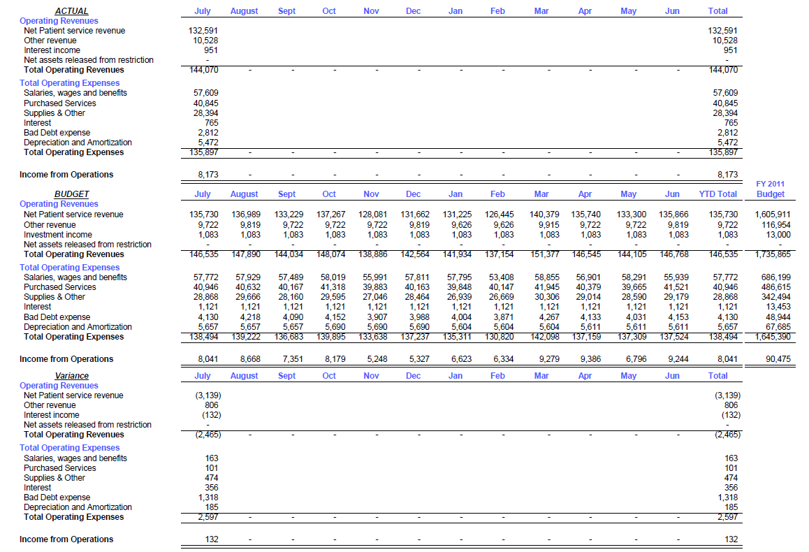

Appendix C
Figure 3

Balance Sheet
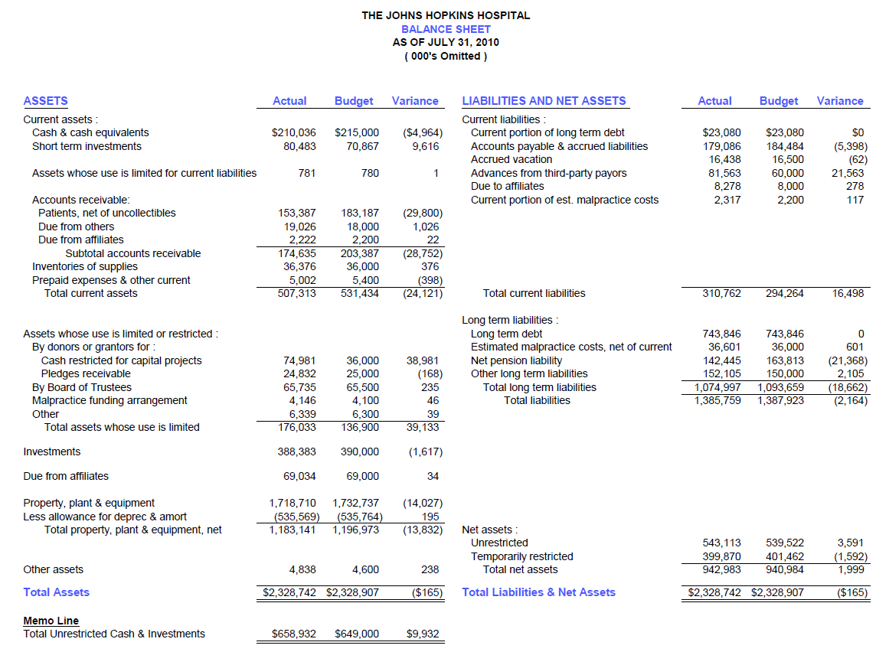
Appendix D

Figure 4

Statement of Cash Flows

