The data from exercise 1 follow.
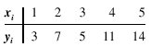
a. Use equation (14.23) to estimate the standard deviation of when x = 4.
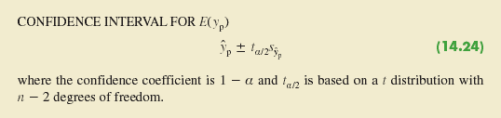
b. Use equation (14.24) to develop a 95% confidence interval estimate of the expected value of y when x = 4.
95% CI = (n1,n2)
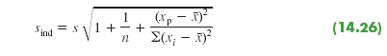
c. Use equation (14.26) to estimate the standard deviation of an individual value of y when x = 4.
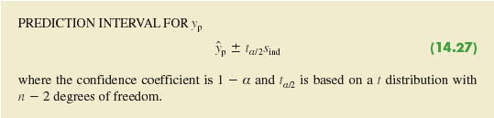
d. Use equation (14.27) to develop a 95% prediction interval for y when x = 4.

