Although Japan is sometimes compared in size to a state such as California, it is probably better to think of it in national terms. In that case, Japan is two-thirds the size of France, one-quarter bigger than Italy or Great Britain, and three-quarters larger than the Korean peninsula. Geographically, the United States, Russia, and China are very big countries, while Japan is something more like "normal size." (see note 1)
But geographic size does not itself determine world power, and "small countries" such as England and the Netherlands once wielded enormous economic and military might. Today, as the second largest national economy after the United States, Japan is a "big country" in terms of economic power.
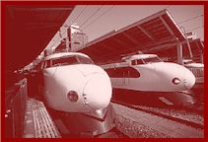 | Why, then, do Japanese people almost always describe Japan as a "small island country"? Because it is small in comparison to the countries that dominated its history: China, the historical great power in East Asia, and the United States, the global superpower in the twentieth century. Japan also seems small to Japanese because it is mostly mountainous, with nearly 80 percent of its 126 million population now crammed into some sixty cities.
And because Japan is a country of four main and many outlying islands, it is indeed surrounded by the sea, which in past times often seemed to protect and isolate Japan from the rest of the world.
But no longer, for there are no island countries in the global economy. So while one understands why Japanese feel their land to be small (and vulnerable), Japan’s size must be measured in relative terms. In natural resources, Japan is tiny compared to Brazil or Canada; in national product, Japan is large compared to Italy or France, though not to the European Union as a whole; militarily, Japan may be big in relation to most of the world’s countries, but it shrinks mightily when the referent is China or the United States; in foreign aid given to other countries, Japan is at present bigger than the United States; and so on. Take a look at The State of the World Atlas to see how the size of countries varies in relation to what is being measured. Size, it turns out, is always relative (see note 2).

Contemporary Japan is a modern society, an instance of the multiple patterns of modernity that characterize the late twentieth-century world. Images of samurai and sumo wrestlers, of geisha and cherry blossoms, should not mislead: Japan is no exotic Lotusland, no topsy-turvy Asian version of Western-style modernity. If modernity, broadly defined, implies industrialization, the nation-state, expanded political participation, forms of middle class or mass society, and growing integration in the world, then there is no single way to be modern, no Western way, no Asian way. Indeed, as any glance at the globe will show, modernity is notoriously uneven in its contemporary appearances. | 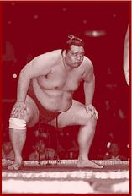

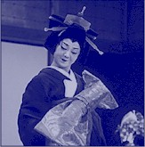 | Yet there are patterns held in common, and modern Japan is a variant of a pattern of modernity, which, though it is by no means the only pattern, is one that Americans know quite well. It includes a capitalistic economy, a democratic politics based on representative parliamentary government, a large middle class as the social basis for both capitalism and democracy, and active engagement in global relations of power (see note 3).

To know Japan today, think first of modernity held in common, first of commonality, and only then of difference.

France and Germany, Canada and Korea are different, too. This is because the common patterns of modernity take various local forms. Capitalism operates differently in different places, shaped by the historical ecology of its surroundings. Compared to the United States, Japan’s "moderated capitalism" has what Americans consider an unacceptably high degree of government involvement in the private sector. Compared to France, the penetration of the political economy by the state seems, in the French context, quite normal. Here one might argue that it is not Japan but the United States that is unusual. In fact, since the United States and Japan are apt to represent the extremes of any particular pattern, it is often better to spread such national comparisons around, looking at Germany, Taiwan, and elsewhere in order to situate better the places of difference.
Democracy, too, is differently construed in different contexts. In Japan democracy tends to be defined socially as coequal access to material and social goods. This social sharing of benefits among the people is considered fundamental, more basic perhaps than political criteria like voting or elections. Democracy in the late twentieth-century world takes many shapes, some emphasizing popular politics, others socioeconomic well-being, but all combining some mixture of both, in different combinations.
The middle classes in Japan reflect the social definition of democracy. Polls report that nearly 98 percent of Japanese consider themselves to be middle-class. Of course, this is a statistical impossibility, since the "middle" disappears if all of society claims to be in it. This all-Japanese-as-middle class is also a social fairy tale, which denies the realities of socioeconomic difference. But it does convey the collectively imagined sense of being coequally well off in livelihood and lifestyle. Rather than striving ever upward in mobility and wealth, this self-declared middle class suggests a social leveling effect that concentrates in the sphere of everyday life, and many people in far less well-off societies envisage democracy in just these terms. Again, Japan is different but scarcely unique.

As suggested by the social definition of democracy, human relations and the social order comprise the primary foundational and operational values in Japan. Overlapping social relationships in the family, community, and the workplace guide the course of individual actions; intersecting social networks determine alignments in business, politics, and the arts. While this is true everywhere, the social web is stronger and more determining in societies like Japan, China, Iran, and many others. (Here again, the Euro-American preference for abstract laws and principles may be considered the world’s exception rather than its rule.)
Preservation of the social order, which supports the web of human relationships, is of primary importance. Actions or persons that disrupt the social order are resisted, while those that support it are encouraged. The result is a strongly coherent and cohesive society capable of considerable feats of change and continuity. But the strength is also a weakness, because its effectiveness depends on social closeness, which excludes people who are not part of the historically created web of connections. For insiders, Japanese society may seem like a warm bath; for outsiders, it is often a cold shower.
To understand and explain phenomena in Japan, whether in politics, economics, culture, or international relations, the guiding principle remains: always seek the social.

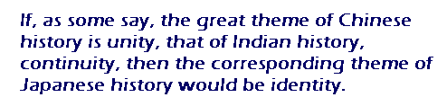

Japanese culture is at once hybrid and extremely open to foreign influence—for centuries, from China; in modern times, from the West—and at the same time, extremely tenacious in the preservation of its own cultural forms. The rapid changes that followed intensive cultural borrowing in the eighth, seventeenth, and nineteenth centuries were soon Japanized into a seemingly seamless appearance of cultural continuity (see note 4).
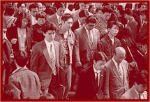 | The two traits are related: from earliest times, Japan looked into the mirror of the foreign and defined itself by its reflection. "Japanese" identity emerged out of close interactions with China. Had cultural relations been more distant, the assertions of "Japanese" identity might not have been so insistent. Long before the challenge of Western imperialism sparked the defensive formation of a modern nation-state and a new reflection of itself in the mirror of the West, Japan had become accustomed to defining itself as "Japanese" against the image of a cultural Other.

If, as some say, the great theme of Chinese history is unity, that of Indian history, continuity, then the corresponding theme of Japanese history would be identity. To understand the ways in which Japan’s strong identity-consciousness was historically produced is not, however, to accept it at face value. | 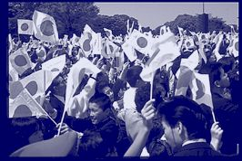
Such concern with identity often takes the ideological forms of nationalism and exclusivism, the more so in uncertain international times when the mirror of the foreign is shaken or in shards, as it seems to be in the 1990s, when we have all to guard against the excesses of our own nationalisms and those of others.

Even when change is extremely rapid, as it was after the Meiji Restoration and after the defeat in World War II, it tends to occur—or to disguise itself as occurring—in incremental fashion. This disguise helps to preserve institutional stability and, even more important, the social order that underlies it. The foreign media stereotype that depicts Japan either as engulfed by headlong change or resistant to any change at all, overlooks this inching incrementalism.
According to my modestly titled "Grand Unified Theory of Japanese History" (the Gluck theorem), the enunciation of crisis in Japan is often dramatic, as it is in the current case of the falling birth rate ("women refuse to marry and bear children") or the economic crisis ("Warning from 2020: When Japan Disappears"). But the actual tempo of change leans toward measured calibration of existing practices and institutions rather than radical measures or frontal attack. Nonetheless, change occurs—or accumulates—sometimes with profound effect (see note 5).
No wonder that the pace of such changes as market-opening and deregulation appears maddeningly glacial to outside (especially American) observers at the same time that it seems faster than quicksilver to Japanese. The rule of measurement is to look to the incremental changes, not to the announced crisis, but to the historical adjustments occurring on or just below the social surface.

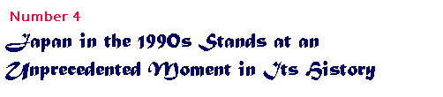
Despite my warning against believing the rhetoric of dire change, it does seem as if the present Japanese sense of confronting a new age is not altogether misplaced. First, there is the point about "no more models," often expressed in the slogan that Japan has now "caught up with and overtaken" the West. If China provided cultural sustenance for centuries and the West appeared as the civilizational model since the late 1800s, then it may be that for the first time in its history Japan has no specific external mirror in which to seek its future and define its identity, but must find the future in and for itself.
Second, and similarly, Japan’s place in the world has changed. Long a part of an East Asian regional order centered on China, Japan sought from the nineteenth century to enter a world order dominated by Euro-American nations. In both instances Japan followed the lead of other, greater powers. Now a world power itself, Japan is called upon not only to follow but to lead—to make an "international contribution," as Japanese say. This new challenge is further compounded by the fact that Japan’s earlier twentieth-century international relations ended badly, in imperialism, war, and defeat. Without long historical experience in setting international agendas and without successful recent precedent in following the agendas of others, Japan does indeed face a new and uncertain world.
Many countries in the 1990s confront similar uncertainties in a post Cold War world that has yet to find a new order of international being. But considering that Japan’s historical strength has been its internal social order with its capacity for adaptive change, dealing with the late-twentieth-century world presents a particularly difficult and seemingly "unprecedented" challenge. As before, domestic social, political, and economic rearrangements are likely to come more easily than the international realignments required to re-place "Japan in the world."

As part of its international realignment, Japan is turning toward Asia for the first time since World War II. Japanese imperialism and aggressive war meant that Japan began the postwar era with a particularly bad past in Asia, and because of its postwar alliance with the United States during the Cold War, Japan spent the next half century facing the Pacific, with its geopolitical back turned toward the Asian mainland. After the end of the Cold War in 1989, Japanese commentators began to talk of "Asianization," often implying a turn away from Euro-America toward Asia.
This Asia-talk in Japan coincided with new Asian initiatives to define Asia on its own terms. The emergence of organizations like APEC (Asia-Pacific Economic Cooperation) began to forge a geo-economic regional identity, and the ideological rhetoric of "Asian values" posited a geo-cultural identity set against that of the West.
For Japan (unlike Malaysia, say) this move toward Asia is fraught with ambivalence. This is because Japanese have yet openly to confront their wartime past to the satisfaction of other Asians, and also because many Japanese do not feel themselves particularly close to Asia after so long an identification with other, Western parts of the geopolitical world.
One of the international challenges for Japan is simultaneously to "re-orient" without turning its back on the West; it has now to face in all directions at once.

Japan must face in all directions precisely because it is a global power. For two decades the sole Asian member of the G-7 group (now, with Russia, G-8), Japan participated in this exclusive club of "advanced industrial economies" that gather in annual summit meetings. Allied with the United States by a security treaty, Japan figures in the American-dominated security structures in the region, and the operations of the Japanese economy have profound impact, not only in Asia, but around the world. While particularly active in Asia, Japan also contributes a great deal to international organizations, and its government would like to have a seat on the United Nations Security Council. These are signs of global power.
Although Japanese frequently speak of a "borderless world" and the proverbial global village, most of Japan’s postwar international activity has been economic. Long dependent on the outside world for trade and natural resources, Japan’s economy is global in its reach. More difficult are the global demands of geopolitics and, in particular, issues of armament and security. Sending uniformed troops abroad, for example, even as part of a UN action, contravenes the popular pacifism that the Japanese public has held since the Second World War.
Nor does Japanese society globalize easily, whether in accepting foreign workers in Japan, or of Japanese "fitting in" in foreign contexts where their accustomed social networks do not operate. But because there is, finally, no retreat from global engagement, incremental changes are occurring even in these most resistant corners of the island country.

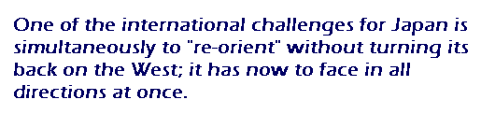

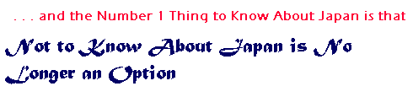
And we need to know not just about Japan but about Japan in its regional setting. And we need to know not about Asia alone but about Japan and Asia in a global context. And we need to know about the globe not merely as a collection of separate regions, but about the interconnections, commonalities, and cross-relations among people (not only among nations). And we need to see the globe not as if it were something "out there" where the rest of the world lives, but to see it as the world we must know about because we depend on it just as it depends on us.

NOTES
1. Henry Smith, "Five Myths about Early Modern Japan," in Ainslie Embree and Carol Gluck, eds., Asia in Western and World History (Armonk, NY: M.E. Sharpe, 1997), p. 515.
2. Michael Kidron and Ronald Segal, The State of the World Atlas, Fifth edition (London: Penguin Books, 1995).
3. See Carol Gluck, "Japan’s Modernities: 1850s–1990s," in Embree and Gluck, Asia in Western and World History.
4. For this and other points mentioned here, see Carol Gluck, "Patterns of the Past: Themes in Japanese History," in Embree and Gluck, Asia in Western and World History.
5. Carol Gluck, "Patterns of Change: A ‘Grand Unified Theory’ of Japanese History," Bulletin of the American Academy of Arts and Sciences, XLVIII, no. 6 (March 1995).

Carol Gluck is the George Sansom Professor of History at Columbia University. Currently Past President of the Association for Asian Studies, her most recent book, which she draws on for this "Top Ten List," is Asia in Western and World History, coedited with Ainslie Embree (M.E. Sharpe, 1997).

