The Cultural Career of the Japanese Economy: Developmental and Cultural Nationalisms in Historical Perspective
Laura Hein
This essay explores the connection between the economy and cultural identity in Japanese nationalism. After World War II Japan was a pacesetter in the global trend toward developmental nationalism, including a transformation of its economy into both a wealthy and a highly egalitarian one. In the 1970s and 1980s, ethnic nationalism re-emerged, with the claim that economic success was the product of Japanese cultural uniqueness rather than of the developmental nationalist policies of the previous quarter-century. The economic downturn of the 1990s thus challenged Japan both economically and culturally, At first, this crisis prompted a critical re-evaluation of national culture, manifested as serious attempts to both resolve tensions with Asia dating from World War II and dismantle domestic social hierarchies. By the mid-1990s, however, this moment had passed and government and business leaders adopted full-fledged neo-liberal policies, reversing the long post-war trend toward income equality, while adopting a more strident and militarist cultural nationalism.
This is the second in a two-article series on developmental and cultural nationalisms. See the accompanying essay by Radhika Desai, Developmental and Cultural Nationalisms in Historical Perspective
Japan’s modern history is unusual in Asia because it was the only Asian country to achieve advanced industrial status in the first half of the twentieth century. Before World War II, it did so through intensive exploitation of the countryside and imperial conquest. After the war, the Japanese re-built their economy along far more egalitarian lines. Nonetheless, while nationalists in Asia faced many of the same conditions and incorporated many of the same elements into their ideas and practices as did their European counterparts, they jointly struggled with the proposition – energetically exported from Europe – that modern national power was somehow uniquely the birthright of Europeans. After defeat in World War II, Japan developed a distinctive and powerful version of developmental nationalism, although this gave way in later decades to cultural nationalism. Like cultural nationalisms elsewhere, not just in Asia, Japanese cultural nationalism, in both its optimistic and pessimistic forms, has provided justifications for social hierarchy and economic inequality, both at home and internationally. Cultural nationalism typically has operated in a way that undercuts commitment to equality of individuals, both at home and internationally. By contrast, arguments for Japan’s normality in the modern world have not been as susceptible to this use historically. [1]
Pre-surrender nationalisms
Modern Japanese nationalism, as elsewhere, emerged within the eighteenth and nineteenth century contexts of globalizing capitalism and imperialism. After establishing a modern state in 1868, and successfully warding off the danger of being colonized, the Japanese began a particularly intensive period of inventing national traditions, drawing on their rich and lengthy indigenous culture. As in most places, the Japanese national project involved homogenizing and subordinating peripheral regions and people. While this pattern was nearly universal, Japan’s particular circumstances were unusual, meaning that in some ways, Japan resembled the colonized world, in other ways early ‘late developers,’ such as Germany, and in yet others, imperial metropoles. Japanese nationalists shared with other non-Westerners the need to confront the fact that Europeans justified and explained their dominance by overt racism. Most late nineteenth and early twentieth-century Japanese were dismayed by Western power and thought of themselves as disadvantaged in the race for development by being Asian. Japanese leaders also shared with other late developers the challenge of coping with a technologically superior capitalist core, which they responded to by emphasizing very state-centred strategies of modern economic development. Indeed, scholars of Japanese nationalism have generally agreed that state-centred nationalism dominated over nationalism imagined around an ethnic community.[2] Japanese modernity was also imperialist and, as in other imperial countries, imperialism and nationalism were mutually constitutive.[3]
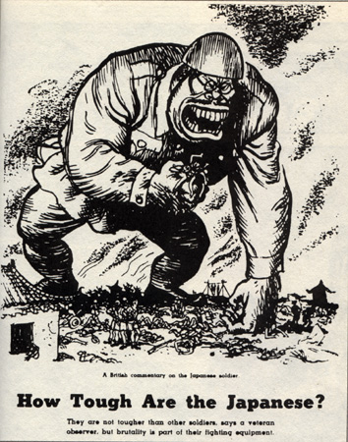
Wartime US image of the Japanese
Rather than the experience of being colonized, pre-war Japanese shared with other Asians the fear that the process of modernization might destroy what they defensively came to think of as the national cultural soul. Anxiety may be at the heart of all nationalisms, but outside the West, its characteristic form is a fear that the price of modernity is Westernization and consequent loss of cultural authenticity.[4] As Dipesh Chakrabarty has argued for India, modern economic thought, like all scientific systems, was a double-edged sword because it offered Asians ‘simultaneous indispensability and inadequacy’: its universal laws imply a common destiny while also suggesting that Asian societies were fundamentally inadequate because they were not culturally Western.[5]
More precisely, the great fear among pre-war Japanese intellectuals was that Japan was losing its cultural identity without fully attaining modernity, creating a deformed hybrid, one that meant continued privation and hampered all chances of normal development. Anxiety over this possibility rose to the level of a cultural panic in the early 1930s in both popular and scholarly thought in Japan, influencing the futures of both developmental and cultural nationalisms.
Pre-surrender Japan thus occupied an unusual middle ground. Although, unlike the colonized world, the Japanese had consistently prevailed on the field of battle and had established a viable industrial economy by 1918, they were still denied entry on equal terms to the salons and scientific laboratories of Europe or citizenship as immigrants to North America. Nor were they ever able to fully control their Asian conquests. That historical experience of sustained military victories and racial exclusion explains much of the specific nature of interwar Japanese anxiety over national identity.
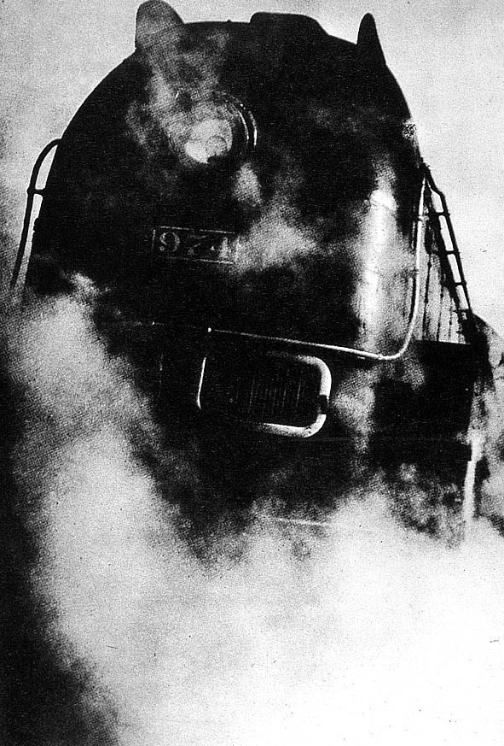
Manchuria Train--Japan's most advanced locomotive at the time, it represented hopes that industrial development in Manchuria would modernize the Japanese economy
The question of whether capitalism was suitable for Japan lay at the heart of much interwar debate and most proponents of Japanese exceptionalism claimed that it did not. Some celebrated Japanese rural social relations as ‘beautiful customs’ that were being destroyed by the inroads of capitalism and selfish individualism. They hoped that rebuilding Japanese agriculture, devastated by rapid changes in global commodity markets in the 1920s and 1930s, would also revitalise national culture. Their cultural analysis much resembled that of romantic fascists everywhere in the 1920s and 1930s, but theorists who emphasised the uniquely Japanese bond between the Emperor and his subjects and the equally unique traditions of the Japanese rural folk rarely acknowledged the resemblance. [6]
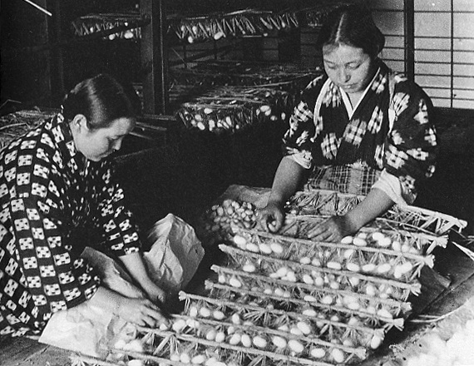
1930s Income inequality was particularly pronounced between urban and rural areas. Here two rural women prepare silkworm cocoons
Other wartime economic policymakers explicitly sought to build on utopian and technocratic fascist ideas to invent a distinctive Japanese modernity, one that celebrated an authoritarian imperial state and rationalised and centralised the economy. The planners at the South Manchurian Railroad Research Department, for example, called for an ultra-modern economy in the colonies in order to transcend what they saw as the deeply flawed economy of the homeland.[7]
Early Post-war Analyses
In 1945 many people recognised that belief in Japanese uniqueness had not only provided a justification for going to war but also had propelled some of the most disastrous military decisions. For example, key strategists within both the Army and Navy had planned victory on the basis of ‘Yamato spirit,’ undervaluing the importance of re-supplying ships or providing air support for troops. The delusional nature of wartime thought rather than poverty now became the new central exhibit in the case for Japanese deformed modernity. The experience of living under a regime that had rejected reality meant that most Japanese were ready for significant change and so provided the opportunity to transform economic institutions, such as farmland ownership patterns and industrial relations practices, that had given small numbers of Japanese so much power over all the others. In other words, the immediate post-war era was the high point both for developmental nationalist policies and for optimism that Japan could move toward normal modernity.
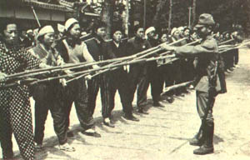
Toward the end of the Asia Pacific War, civilians were told to protect the home islands with sharpened bamboo stakes, epitomizing the insistence that national spirit could overcome a dearth of resources
Japan developed a distinctive and powerful version of developmental nationalism in the first decade after World War II. During this time, the sense of Japanese uniqueness that had undergirded pre-surrender nationalism was muted in favour of an emphasis on what Japan had in common with the rest of the advanced industrial world. Early postwar governments committed to an economic strategy based on high wages, high labour productivity, and a peace-based economy, none of which had characterised pre-war Japan.[8] They laid the foundations for the developmental nationalist approach that characterised Japan for the next quarter-century, leading to both high-speed economic growth and to the extraordinary reduction of poverty over the next three decades. These priorities reflected a global postwar trend toward policies that Peter Katzenstein has called ‘tamed capitalism,’ or policies that harnessed the market.[9] Typically these modernizing developmental nationalists criticized older national traditions for enshrining social and cultural hierarchies and also pursued policies that promoted social equality.
By the 1960s, Japanese views of the nature of Japanese capitalism were profoundly affected both by this new international context epitomised by the Cold War and by the experience of high-speed economic growth. By 1970, even the economic thinkers who focused on the ‘dual economy’ [niju kozo], ‘distortions of growth’ [keizai seicho no hizumi], and uneven development, such as Arisawa Hiromi, treated these conditions as normal problems to be managed rather than evidence of unique cultural impediments to modernity. Rising standards of living and diminishing poverty levels fuelled optimism that such impediments could be overcome. Economic equality seemed to be evolving from a tamed form of capitalism to a welfare-state system. Most economic criticism now came from individuals such as Tsuru Shigeto, Miyamoto Ken’ichi, and Uzawa Hirofumi, who offered an environmental critique of the ‘production-first’ bias of Japan’s developmental nationalism while still remaining sympathetic to its other dimensions.[10] Most of them also combined criticisms of Japan with criticisms of the United States, demonstrating that capitalism itself rather than deviant Japanese culture was the chief problem as they saw it. In other words, post-war economic theorists remained highly critical of the rural past, as did other developmental nationalists around the world, but, since the countryside was rapidly being integrated into urban prosperity, the question of why it had been so poor no longer engaged people as intensely. Moreover, both celebrants and critics of Japan’s economy in the 1960s and early 1970s treated the contemporary Japanese economy as normal rather than deviant, regardless of their views of the pre-surrender years.
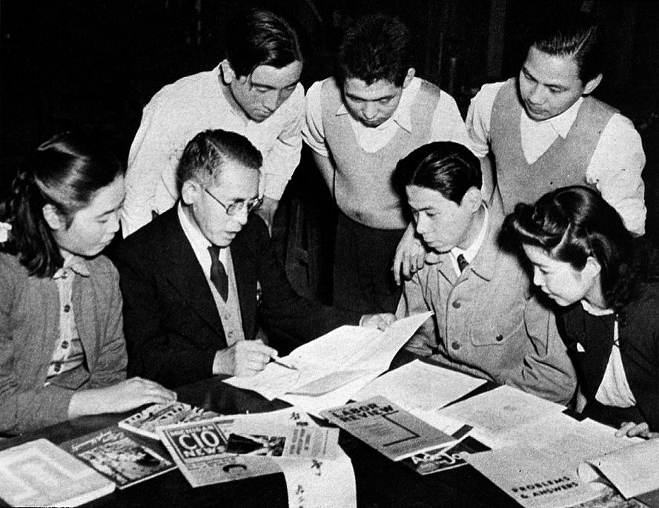
The Tokyo Labor College was one of the many institutions created after the war in order to promote more equitable economic development than had existed before
The Return of Unique Japan
Theories of Japanese uniqueness never completely disappeared, however. While they were muted in the 1950s and 1960s when developmental nationalist strategies were in the ascendant and exceptionalism was most strongly associated with wartime disaster, the international climate changed again in the mid-1970s, sparking a combustible mix of nationalist anxiety and pride. The two ‘oil shocks’ and U.S. President Richard Nixon’s resumption of diplomatic relations with China, which he pursued without informing Japan, reminded the Japanese that the international economic and political environment could still deliver nasty surprises.
Japan’s phenomenal rise in the global economic arena meant that these issues seemed surmountable, but they did send many people in search of new ways to explain Japan to themselves and the world. The popular press in particular responded with a profusion of Nihonjinron analyses of Japanese uniqueness in the 1970s and 1980s. Nihonjinron literature reverted back to the pre-war argument that Japan was blessed by being fundamentally different from elsewhere, although now the focus was on the economy and resolutely not on the state, which would have brought attention back to the disaster of the war. Significantly, cultural nationalism in Japan of the 1970s and 1980s, like postwar developmental nationalism before it, still operated by sublimating military aspirations rather than by representing them.[11]
Why did these arguments flourish? Nihonjinron discussion was rarely rigorously comparative (primarily because analytic rigor would have shredded the argument beyond repair). But it could tap anxiety about Japan’s historical deviance, which had remained dormant during the 1950s and 1960s, but flared up in response to new challenges in Japan’s international environment. The alacrity with which foreign judgments about Japan have been translated, discussed, accepted, and refuted within the domestic Japanese public sphere suggests that the spark for this anxiety is transnational. Japanese nationalism has always developed in dialogue with the outer world. Fear that Japanese would never be fully welcome was an abiding source of anxiety, and a recurrent trigger for assertions of difference.[12] Moreover, the turn to cultural nationalisms was part of a global historical movement.
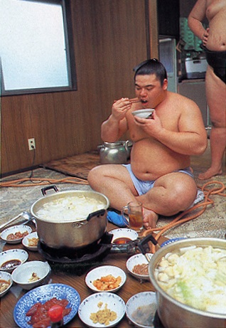
Cultural nationalism in the 1970s and 1980s celebrated the unique nature of such traditions as sumo wrestling, including the hierarchical "stable" system and such rituals as participants' special diet
In Japan the connection between economic inequality and the rise of cultural nationalism was far less pronounced because incomes had converged so much in the early post-war decades. Indeed, postwar Japanese cultural nationalism developed before the onset of any crisis in Japan’s developmental strategy and before neoliberal economic policies were adopted. Post-war social homogeneity was built on Japan’s high level of income equality, something that is neither traditional nor acknowledged in the Nihonjinron literature. Like other cultural nationalists in the 1970s Japanese Nihonjinron advocates did strip away some of the justifications for developmental nationalist policies, although the policies continued unchecked. For example, many of these authors argued that cultural homogeneity, rather than rises in real incomes among the working class, explained minimal levels of strife between workers and managers within Japanese firms, ignoring the extremely high levels of such strife until incomes really rose in the 1960s. In other words, in the 1970s and 1980s, when an important spur to cultural nationalism elsewhere in Asia was the compensatory need to explain poverty and also growing inequality, Japanese of those decades could boast of economic success as the great validating feature of national culture.
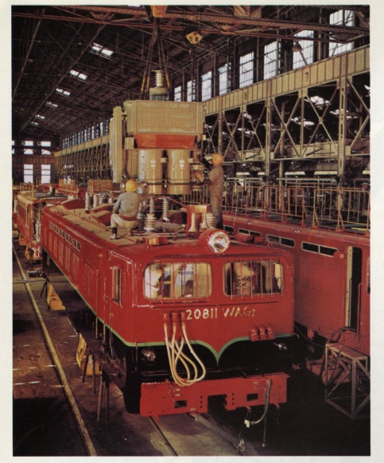
Postwar Japanese industrial development was based on stable, well-paid manufacturing jobs
The 1990s: Economic Downturn and Its Consequences
By the 1990s, however, the nationalist celebration of Japanese difference had attracted so many adherents that when the economy plummeted in 1990, weighed down by bad loans and overvalued real-estate and stock markets, it took many Japanese by surprise, and instantly revived fears both of congenital deformity and of international isolation. Cultural analyses could no longer rest on the automatic validation that economic success had provided. Moreover, the recession deeply affected people’s lives. The unemployment rate, which had been very low since the 1960s, shot up, and for the first time in decades many Japanese felt anxious about their personal circumstances as well as about the nation. This new state of affairs eventually polarized public opinion as Japanese debated whether to embrace cultural transformation or limit it, how to approach the international world, and whether to shore up the now-faltering developmental state or to adopt neo-liberal reforms.
For a time domestic Japanese debate seemed to be leading toward a critical re-evaluation of the economy, national culture, and the relationship between them. Miyazaki Yoshikazu’s 1992 book, Compound Recession [Fukugo fukyo], set out to refute both Nihonjinron and other analyses that focused on the domestic economy in isolation from the global one. His call for a return to developmental nationalist principles at home and recognition of the many complex ways in which Japanese economic institutions were fully integrated into the global economy sold over three million copies in the first year. Miyazaki, an eminent economist until his death in 1998, argued that recent higher levels of international integration of the major developed economies, together with financial deregulation, had led to asset bubbles in the United States, Europe, and Japan, which all burst in the 1980s and early 1990s. Using the analogy of ‘combined pollution,’ which creates a far greater problem than the sum of the various pollutants alone, Miyazaki argued that these global developments caused a ‘compound recession’ unlike any seen before. He also stressed the fact that Japan had fully participated in creating that environment rather than being its passive victim.[13]
Like Paul Krugman, whose ideas are also well-known in Japan, Miyazaki held that the glut of bad loans in Japan depressed demand globally and thwarted investment in Japan and elsewhere. Moreover, he argued, not only did the various sectors of national economies now operate in relation to each other differently than they had in the past, but also global production had ‘uncoupled’ the nationality of firms from employment. Along with the growing importance of capital movements, these were permanent unwelcome changes not just in Japan but also in Europe and the United States. Returning to one of the central premises of developmental nationalists, Miyazaki believed that governments have an obligation to balance market efficiency with the social welfare needs of their citizens. Indeed, he argued that, like pollution, this ‘economic externality’ could not be addressed by market means alone, which is why the growing independence of large firms from national governments is a problem.
Meanwhile, at first it seemed as though cultural nationalism was on the wane in areas other than the economy. Stellar economic performance had become so closely associated with Japanese cultural uniqueness that the economic setback also reopened debate about Japan’s national identity. The early 1990s saw major efforts among both government officials and the general population to reshape Japan’s relations with the world, especially Asia, in a far more respectful and equal way. Japan’s bookstores and airwaves overflowed with discussion about Japan’s wartime and imperial past, and the first Socialist Prime Minister since 1947, Murayama Tomiichi, issued a statement in 1995 apologizing for Japan’s conduct in World War II.[14] All the major language schools were deluged with students learning Asian languages, and the government seriously considered liberalizing immigration rules. Domestically, resident Koreans gained new rights and public opinion shifted markedly toward embracing the desirability of a distinctive Okinawan-Japanese identity and the obligation of firms to control sexual harassment of their female employees. Young people began exploring new directions, some striking out on their own when the standard “lifetime-employment” path suddenly appeared uncertain at best. In other words, the early 1990s were economically stagnant, but also represented an unusually open and dynamic moment culturally. The Japanese seemed to be moving toward a more cosmopolitan and heterodox notion of national identity.
However, other Japanese drew a different lesson from the economic crisis. They saw the post-war institutions of economic success that had been celebrated as uniquely functional expressions of traditional culture in the 1970s and 1980s as the source of Japan’s problems because they hindered neo-liberal economic reforms. Economist Noguchi Yukio was the most energetic voice calling for neo-liberal reform in the 1990s. Revising his earlier views that Japan had a normal capitalist economy, Noguchi argued that the Japanese ‘developmental state’ was an obstacle to healthy economic development. He reserved his harshest criticism for the government, calling for greater freedom for the market. Noguchi held that Japan was locked in ‘the 1940 system’ and that it desperately needed to break free of its wartime institutional constraints by dismantling a variety of public regulatory systems. These included subsidies to banks, industry, and agriculture, government barriers to competition among firms and between economic sectors, and such practices as lifetime employment and seniority wages. Some of these systems were established during the war and some in the Occupation years, which Noguchi treated as a single ‘1940s’ unit. While highly respected among his peers as a scholar, Noguchi is also a gifted populariser and his essays and books are widely read by the general public, including at least one national business-list best-seller.
By the mid 1990s, government and business leaders finally adopted neo-liberal policies on a massive scale, ending Japan’s exceptionally long commitment to developmentalist economic institutions. When they stepped away from practices such as lifetime employment and seniority-based wages, Japanese leaders did so on the grounds that they were too traditional, even though they were in fact modern—indeed, largely post-war – innovations. Since these were the very mechanisms that had equalised incomes in the early post-war decades, by 1997 the reforms had definitively reversed the long post-war trend toward income equality for the first time since 1945.[15]
In the mid-1990s, just as social inequality mounted, a relatively small number of influential figures built a classically compensatory cultural nationalist movement, asserting the right to national pride, including an offensive military force, and blaming foreigners for all of Japan’s troubles. Ishihara Shintaro, the novelist-turned-politician, epitomised this trend in his 1998 book, The Japanese Economy That Can Say NO! which catapulted to top-ten business-list status. No longer using economic strength as the marker of cultural superiority, Ishihara instead celebrated the belligerency of the wartime state. His call for greater reliance on the market economy is also similar to that of Noguchi Yukio, although Noguchi saw such measures as the path to normalcy and Ishihara believed they would liberate Japanese exceptionalism. [16]
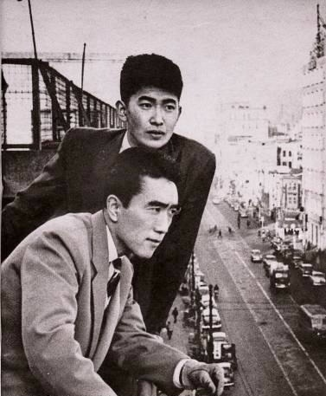
Ishihara Shintaro in 1956 with fellow novelist Mishima Yukio (foreground)
Ishihara’s personal theme since his debut as a prize-winning novelist in the 1950s has been a celebration of self-confidence and defiant assertion of power. Since entering politics, first as a member of the Diet and then as governor of Tokyo since 1999, he has nationalised this theme. According to Ishihara, Japan’s economic problems in the 1990s were caused by American manipulation of the international financial system specifically in order to subordinate Japan. The echoes with pre-war rightwing analysis are disturbingly loud, as is the underlying anxiety about national decline. (His views also mirror 1980s American rhetoric about Japanese economic warfare in that he echoes the argument that Japanese economic success was based on unfair state intervention, making it clear that this is his primary target.) Ishihara is well-known for his insistence that the Nanjing Massacre never took place, his approving use of the war-time conception of Japan as the leader of a ‘Greater East Asia Co-Prosperity Sphere,’ and his deliberately insulting comments as governor that ‘third-country nationals,’ meaning resident Koreans and Chinese, pose a danger to other Tokyoites. (This Occupation-era term refers to former colonial subjects who were stripped of citizenship, leaving many stateless.) Yet after the Japanese economy turned sour, he has also staked out the position that Japan must cooperate with other Asian countries against the imperialist, arrogant Western powers. Like other Japanese cultural nationalists who adopt this position, he assumes that Japan will be the leader of Asia rather than a partner in more equitable arrangements. [17]
Ishihara glories in deliberately provocative language, often choosing images that combine his longstanding interest in masculine sexual domination with his newer concern for Japan’s international standing. He opened his 1998 book with the argument that ‘the Japanese economy is America’s concubine with bound feet’. This image of poor Japan tottering on mangled ‘lotus feet’ is a bizarre twist: it claims cultural continuity for a practice that was never adopted in Japan nor in most other Asian nations, indirectly associates foot-binding with Western imperialism, and highlights his contemptuous-yet-fascinated stance toward China. The image does work to emphasise his central themes: that Japan has handicapped itself by failing to aggressively demand power, and, as a result, is now suffering from feminized, Orientalized, and old-fashioned dependence on others for even the most basic needs. For those familiar with Ishihara’s work, it is unnecessary to add that in his case feminised means emasculated.[18]
Prime Minister Koizumi and his successor Abe Shinzo essentially followed Ishihara’s lead on both cultural and economic matters, and since 2001 the trend toward both neo-liberalism and compensatory cultural nationalism has become far more pronounced. Rather than focusing, as they had in the 1970s and 1980s, on domestic cultural arrangements that supposedly benefited all Japanese materially and emotionally, such as consensus-decision making or lifetime employment, cultural nationalists in the government punished school teachers who failed to sing the new national anthem and municipal governments that did not display the new national flag, both established as official practices in 1999. Koizumi championed neo-liberal economic reforms, particularly the privatization of the vast banking service that had operated through the postal system. As Gregory Noble, a political scientist at the University of Tokyo, noted:
One of the most striking aspects of policy debates in Japan today is the complete absence of an articulate and coherent alternative to neo-liberalism, even though surveys of both the public and Diet members reveal a deep-seated preference for a significant or even extensive governmental role in upholding social stability….The neo-liberal movement energetically spearheaded by Prime Minister Koizumi has succeeded in presenting itself as the only solution to the stagnation and corruption of vested interests, even though it is itself a minority opinion supported by a relatively narrow range of interests from the internationally exposed sectors of the economy.[19]
Koizumi combined this economic program with an insistence on making official visits to Yasukuni shrine, even though his actions damaged Japan’s diplomatic relations with China. His successor in 2006, Abe Shinzo, while declining to publicly visit Yasukuni, was even more hawkish on issues of war remembrance and essentially rescinded Japan’s acknowledgment both at the Tokyo War Crimes Trials and by Prime Minister Murayama that the wartime government had enslaved an estimated 80,000-200,000 foreign women to provide sex to the military.[20]
The strident nationalism of contemporary Japanese leaders not only reeks of bullying and sullen resentment directed at foreigners, domestic minorities, and women, it also seems to bear no useful relationship to Japanese national economic or strategic interests. Ironically, cultural nationalisms in contemporary India and China, with their red-hot economies, may soon look as sunnily boastful as did Japanese cultural nationalism in the 1970s and especially the 1980s – without Japan’s lingering commitment to developmental nationalism or its pacifism – while the Japanese trajectory seems to be toward the kind of cultural justification of economic inequality that characterized India in the same decades. In this sense, Japan at the dawn of the twenty-first century is more like the United States, where nationalist rhetoric also sounds far less self-confident and more sullenly resentful than in the early post-war decades, and is similarly accompanied by foreign policies that alienate people elsewhere without advancing American national interests.[21]
Laura Hein is a professor in the Department of History, Northwestern University and a Japan Focus coordinator. Her most recent book is Reasonable Men, Powerful Words: Political Culture and Expertise in 20th Century Japan. The Japanese edition was brought out by Iwanami Press in 2007.
This article was prepared for Japan Focus and posted on June 26, 2008.
NOTES:
1. One can of course imagine scenarios in which such arguments perform exactly the same ‘cultural work’ as have arguments for Japanese uniqueness.
2 S. Vlastos, Mirror of modernity: invented traditions of modern Japan, Berkeley: University of California Press, 1998. T. Fujitani, Splendid Monarchy: Power and Pageantry in Modern Japan, Berkeley: University of California Press, 1996. C. Gluck, Japan’s Modern Myths, Princeton: Princeton University Press, 1985. H. D. Harootunian, Overcome by Modernity: History, Culture, and Community in Interwar Japan. Princeton University Press: 2000. E. Oguma, A Genealogy of ‘Japanese’ self-images. Melbourne: Trans Pacific Press, 2002, Japanese ed. 1995. D. Stegewerns, Nationalism and Internationalism in Imperial Japan: Autonomy, Asian Brotherhood, or World Citizenship?, London: RoutledgeCurzon, 2004.
3 T. Nairn, The Break-up of Britain: Crisis and Neo-nationalism, London: NLB, 1977 an P. van der Veer, Imperial Encounters: Religion and Modernity in India and Britain, Princeton: Princeton University Press, 2001, show how the two developed together in Britain.
4. Loss of cultural authenticity per se has always accompanied modernity as the market, urbanization, and rationalization erode older cultural patterns. The difference is that Americans, Germans, and other Westerners were less likely to see these problems as imported wholesale from elsewhere. See R. Desai, ‘Nation against Democracy: The Rise of Cultural Nationalism in Asia,’ in F. Quadir and J. Lele, eds., Democracy and Civil Society in Asia, vol. 1 Basingstoke: Palgrave Macmillan, 2004, pp. 81-110. T. Najita and H. D. Harootunian, ‘Japanese Revolt against the West: Political and Cultural Criticism in the Twentieth Century’. The Twentieth Century, vol 6. P. Duus, Ed. The Cambridge History of Japan Cambridge: Cambridge University Press, 1988.
5. D. Chakrabarty, Provincializing Europe: Postcolonial Thought and Historical Difference. Princeton University Press, 2000. p. 6. T. Winichakul has developed the point about attention to imperialism even in non-colonized areas in, Siam Mapped: A History of the Geo-body of a Nation, Honolulu: University of Hawai’i Press, 1994.
6. Harootunian and Najita, ‘Japanese Revolt against the West’.
7. L. Young, Japan’s Total Empire: Manchuria and the Culture of Wartime Imperialism. Berkeley: University of California Press, 1998, Japanese edition, 2001. Y. Yamanouchi, J. V. Koschmann, and R. Narita, eds., Total War and ‘Modernization’. Ithaca, NY: Cornell East Asia Series, 1998.
8. See The Special Survey Committee, Ministry of Foreign Affairs. Ed. Reconstruction of the Japanese Economy. Tokyo: University of Tokyo Press, 1992. Also see Hein, Reasonable Men, Chapter 4.
9. P J Katzenstein, Tamed Power: Germany in Europe, Ithaca NY: Cornell University Press, 1997.
10. For representative examples, see Sekai, which published 102 articles by Tsuru, 19 by Uzawa, and 41 by Miyamoto between 1946 and 1995. Sekai Somokuji: 1946-1995, Tokyo: Iwanami, 1995.
11. H. Befu, Hegemony of Homogeneity, p. 14 dates the explosion of Nihonjinron literature to the 1960s but the cumulative effect of this argument really gained far greater momentum in the following decade. See Chapter 5 for argument about national flag. T. Fujitani, ‘Inventing, forgetting, remembering: toward a historical ethnography of the nation-state’, in Befu, ed. Cultural Nationalism in East Asia emphasises the disappearance of the empire.
12. Befu, Hegemony of Homogeneity and H. Befu, ed. Cultural Nationalism in East Asia: Representation and Identity, Research papers and policy studies; 39; Berkeley, CA: Institute of East Asian Studies, University of California, 1993
13. Y. Miyazaki, Fukugo Fukyo: posuto baburu no shohosen o motomete (Compound recession: toward a prescription for the post-bubble economy). Tokyo: Chuo Koronsha, 1992 (22cd printing by 1998). Also see K. Miyamoto, Nihon Shakai no Kannosei: Iji Kanno na Shakai e, (The Possibility of Japanese society: toward a self-sustaining society), Tokyo: Iwanami Shoten, 2000.
14. The official translation is available here.
15. C Moriguchi and E Saez, ‘The Evolution of Income Concentration in Japan, 1886-2005: Evidence from Income Tax Statistics,’ Review of Economics and Statistics, Forthcoming.
16. S. Ishihara and Hitotsubashi Sogo Kenkyujo. ‘No’ to ieru nihon keizai; sensen fukoku: America no kinyu dorei kara no kaiho. (The Japanese economy that can say ‘no’; liberation from American financial slavery’.) Tokyo: Kobunsha, 1998. For a discussion of Ishihara’s economic policy, see A. DeWit and M. Kaneko, ‘Ishihara and the Politics of his Bank Tax,’ JPRI Critique, IX.4 May 2002.
17. S. Ishihara, ‘Tawara Soichiro no kakuto taiwa: ima koso jitsugen dekiru ‘Dai Toa Kyoeiken (No-holds-barred debate with Tawara Soichiro: Now is the time to realise the ‘Greater East Asia Co-Prosperity Sphere,’ Sansara. July 1991: 44-59. J. Nathan, Japan Unbound: A Volatile Nation’s Quest for Pride and Purpose. Boston: Houghton Mifflin, 2004, pp. 191-2. S. Ishihara and M. Mahathir, ’No’ to ieru Ajia: Tai-obei e no hosaku. Tokyo: Kobunsha 1994 was also a best seller.
18. Nathan, Japan Unbound, Chapter 7.
19. G. W. Noble, ‘Koizumi and Neo-liberal Economic Reform,’ Social Science Japan, March 2006, pp. 6-9, esp. p. 9.
20. When the Japanese government accepted the judgment of the Tokyo Trials, it acknowledged the enslavement of Dutch women in the Netherlands East Indies but not the Asian women who suffered the same fate.
21. T. Franks, What’s the Matter with Kansas? How Conservatives Won the Heart of America, NY: Metropolitan Books, 2004 makes the argument for the domestic basis of this stance, one that sounds very much like the compensatory cultural nationalism discussed in this collection.

