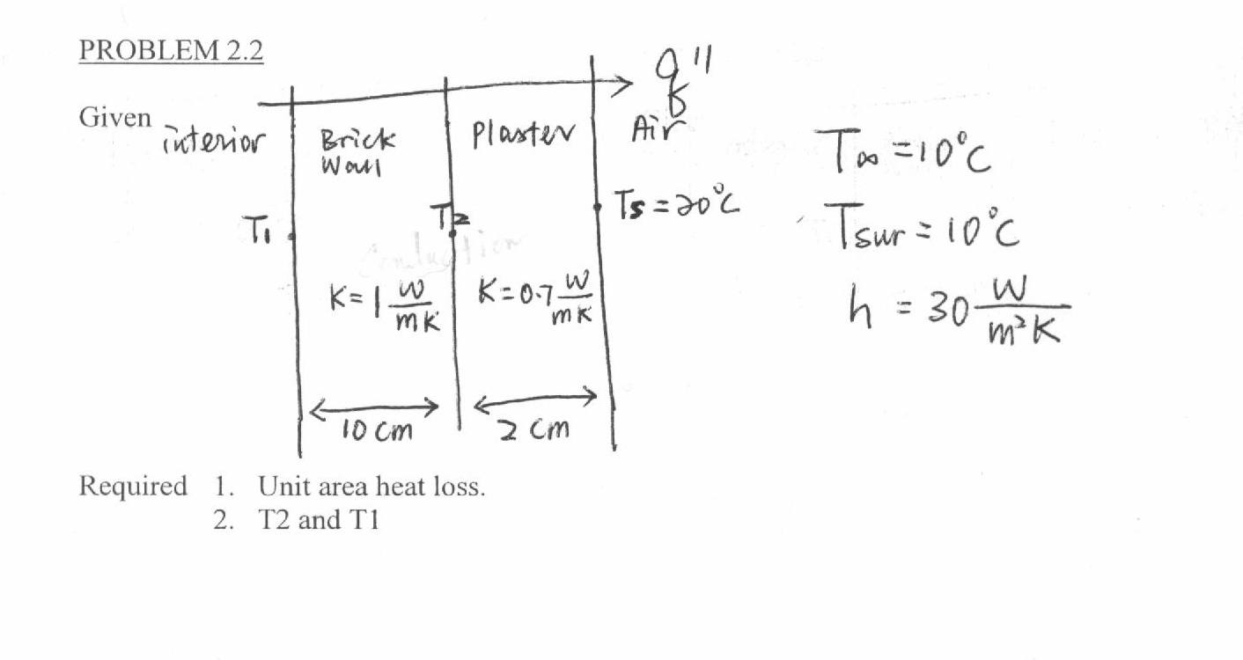
I’m not sure how to do this at all. I know the q” equations for conduction and convection come into play somehow, right? Also, could you please explain to me where conduction is taking place here and where convection is taking place? Is there radiation also? Thanks!

