The U.S. Navy selected 16 hospitals that it believes to be efficiently run and conducted a regression analysis to evaluate the performance of its hospitals in terms of how many labor hours are used relative to how many labor hours are needed.
The variables assigned for this analysis are:
y = monthly labor hours required
x1 = monthly X-ray exposures
x2 = monthly occupied bed days (a hospital has one occupied bed day if one bed is occupied for an entire day)
x3 = average length of patients’ stay (in days)”
Refer to the MegaStat output below to answer these questions A through D.
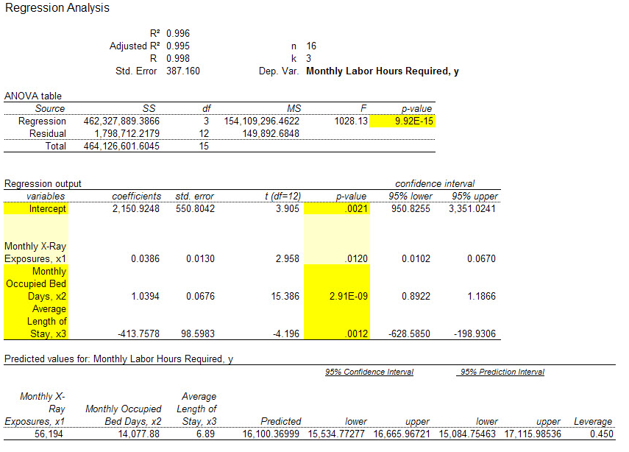
(A) Analyze the above output to determine the multiple regression equation.
(B) What conclusions are possible using the result of the global usefulness test (F test)?
(C) What conclusions are possible using the results of the t-tests of the independent variables (alpha = 0.05). Does this data provide significant evidence (alpha = 0.05) that the monthly labor hours required is associated with monthly X-ray exposures and/or monthly occupied bed days and/or average length of patients’ stay (in days)? Find the p-values and interpret.
(D) Using the table below, predict the monthly labor hours required when the X-ray exposures are 56,194, the bed days are 14,077.88, and the average length of patients’ stay is 6.89.

