Question 1: Marketing Communications and Customer Response (Use Figure Below)

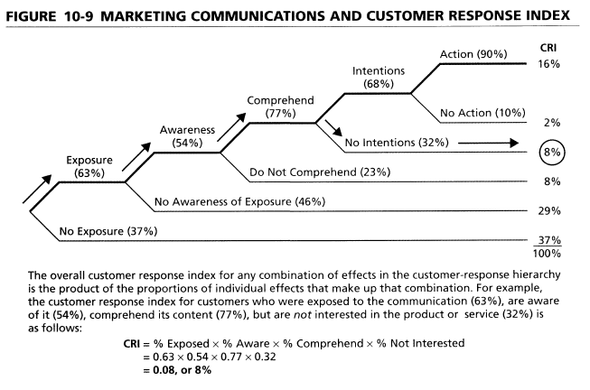
- Using the data provided, how do the results of this marketing communication change when advertising exposure is only 50 percent?

- Using the results provided, evaluate the impact of improving ad awareness from 54 to 68 percent. What are your findings?
- For future advertisements, would it be more effective to work on increasing comprehension by 5 points (from 77% to 82%) or to work on improving intentions to purchase by 5 points (from 68% to 73%)?

Question 2: Customer Value Analysis (Use Figures Below)

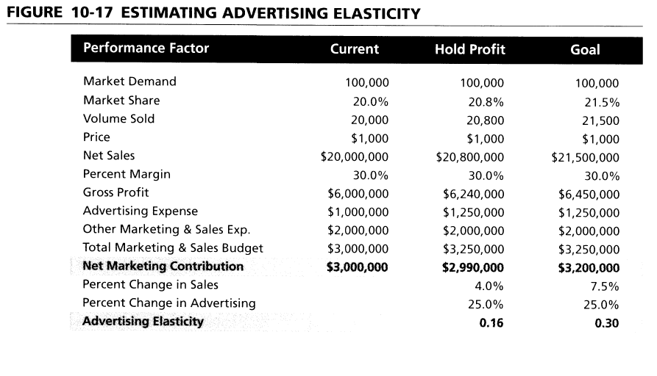

- Using the data provided, how does the advertising elasticity change when the increase in sales after advertising is 10 percent instead of 4 percent??
- What would be the profit impact if the advertising budget were increased as proposed but sales do not change?

