Question 21 (Multiple Choice Worth 4 points)
The following is an opportunity-loss table.
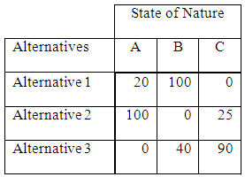
The probabilities for the states of nature A, B, and C are 0.3, 0.5, and 0.2, respectively. If a person were to use the expected opportunity loss criterion, what decision would be made?
Alternative 1
Alternative 2
Alternative 3
State of Nature C
State of Nature B

