Use the following to answer questions 26-27:

On its December 31, 2007 balance sheet, Klugman Company appropriately reported a $10,000 debit balance in its Securities Fair Value Adjustment (Available-for-Sale) account. There was no change during 2008 in the composition of Klugman's portfolio of marketable equity securities held as available-for-sale securities. The following information pertains to that portfolio:
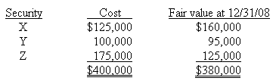

26. | What amount of unrealized loss on these securities should be included in Klugman's stockholders' equity section of the balance sheet at December 31, 2008?
 | A) | $30,000.
 | B) | $20,000.
 | C) | $10,000.
 | D) | $0.

27. | The amount of unrealized loss to appear as a component of comprehensive income for the year ending December 31, 2008 is
 | A) | $30,000.
 | B) | $20,000.
 | C) | $10,000.
 | D) | $0.

