Consider the circuit shown in Figure P1-14 on page 41 of your textbook. Find the unknown currents $I_{1}, I_{2}$ and the voltage across the resistance R.
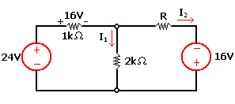

Refer to the circuit shown in Figure P2-14 on page 115 of your textbook. What are the currents $I_{2}$ and $I_{3}$?
