The circuit is on the left and my answer is on the right. Can you explain what I did wrong in these two circuits please?

Find the Thevenin equivalent voltage and current for the network shown in Figure 1-2 below if $V_{1}=6V, R_{1}=4Ω, R_{2}=8Ω$
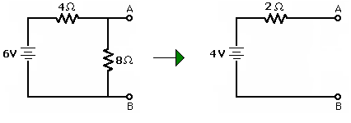

Find the Norton equivalent circuit to Figure 1-2.

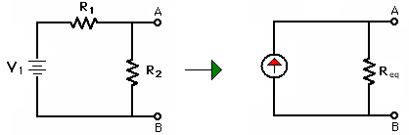

Figure 1-2: Circuit for problem 9

