Chi-square distribution
Use the calculator provided to solve the following problems.
- Suppose that follows a chi-square distribution with degrees of freedom. Compute 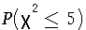. Round your answer to at least three decimal places.
- Suppose again that follows a chi-square distribution with degrees of freedom. Find such that 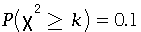. Round your answer to at least two decimal places.
- Find the median of the chi-square distribution with degrees of freedom. Round your answer to at least two decimal places.

P ($x^{2}$ ≤ 5) =
K =
Median =

