Glenda Everson
Math 1002 Practice Problems

Week 3

1. Write the negation of the statement.
No one likes asparagus.

2. Determine the truth value of the statement if
- a)p is true, q is false, and r is true.
- b)p is false, q is true, and r is true.
∼q ∨ (r Λ p)

3. Determine whether the argument is valid or invalid. You may compare the argument to a standard form. Also construct a truth table.

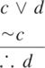

Week 4 – Geometry
1. Use the figure to find the following:
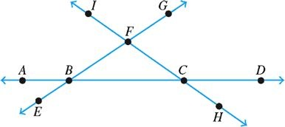

2. (a) Use the Pythagorean theorem to determine the length of the unknown side of the triangle, (b) determine the perimeter of the triangle, and (c) determine the area of the triangle.

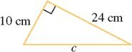

3. Determine (a) the area and (b) the perimeter of the figure.

