1. The word that comes from the Greek word for "one who manages a household" is (Points :1)
market.
consumer.
producer.
economy.
2. In an economy in which decisions are guided by prices and individual self-interest, there is (Points :1)
the potential to achieve efficiency in production.
a strong need for government intervention in the market.
less efficiency than would be observed in a centrally-planned economy.
more need for a strong legal system to control individual greed than would be needed in a centrally-planned economy.
3. In the circular-flow diagram, in the markets for (Points :1)
goods and services, households and firms are both sellers.
goods and services, households are buyers and firms are sellers.
the factors of production, households are buyers and firms are sellers.
the factors of production, households and firms are both buyers.
4. Figure 2-5
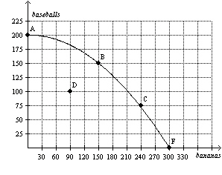
Refer to Figure 2-5. If this economy moves from point A to point B, then which of the following statements is correct? (Points :1)
This economy has moved from a point of inefficient production to a point of efficient production.
This economy has experienced economic growth.
This economy has experienced an increase in employment.
None of the above is correct.
5. Assume for the United States that the opportunity cost of each airplane is 100 cars. Then which of these pairs of points could be on the United States' production possibilities frontier? (Points :1)
(200 airplanes, 5,000 cars) and (150 airplanes, 4,000 cars)
(200 airplanes, 10,000 cars) and (150 airplanes, 20,000 cars)
(300 airplanes, 15,000 cars) and (200 airplanes, 25,000 cars)
(300 airplanes, 25,000 cars) and (200 airplanes, 40,000 cars)
6. Suppose Jim and Tom can both produce baseball bats. If Jim’s opportunity cost of producing baseball bats is lower than Tom’s opportunity cost of producing baseball bats, then (Points :1)
Tom must have an absolute advantage in the production of baseball bats.
Jim must have an absolute advantage in the production of baseball bats.
Tom has a comparative advantage in the production of baseball bats.
Jim has a comparative advantage in the production of baseball bats.
7. Table 3-2
Assume that Aruba and Iceland can switch between producing coolers and producing radios at a constant rate.
Labor Hours
Needed to Make 1
 | Cooler | Radio
Aruba | 2 | 5
Iceland | 1 | 4
Refer to Table 3-2. Aruba and Iceland would not be able to gain from trade if Iceland's opportunity cost of one radio changed to (Points :1)
0 coolers.
0.25 coolers.
2.5 coolers.
Aruba and Iceland can always gain from trade regardless of their opportunity costs.
8. Table 3-4
Assume that the farmer and the rancher can switch between producing meat and producing potatoes at a constant rate.
 | Labor Hours Needed  to Make 1 Pound of |  | Pounds Produced  in 40 Hours
 | Meat | Potatoes | Meat | Potatoes
Farmer | 10 | 2 | 4 | 20
Rancher | 4 | 8 | 10 | 5
Refer to Table 3-4. The farmer has an absolute advantage in the production of (Points :1)
meat.
potatoes.
both goods.
neither good.
9. Table 3-6
Assume that Hilda and Carlos can switch between producing quilts and producing dresses at a constant rate.
 | Hours Needed  To Make 1 |  | Amount Produced  in 90 Hours
 | Quilt | Dress | Quilts | Dresses
Hilda | 30 | 10 | 3 | 9
Carlos | 90 | 45 | 1 | 2
Refer to Table 3-6. Which of the following combinations of quilts and dresses could Carlos not produce in 90 hours? (Points :1)
0 quilts and 2 dresses.
0.5 quilt and 1.5 dresses.
0.75 quilt and 0.5 dress.
1 quilt and 0 dresses.
10. Table 3-7
Assume that Japan and Korea can switch between producing cars and producing airplanes at a constant rate.
 | Hours Needed  to Make 1 |  | Quantity Produced  in 2400 Hours
 | Car | Airplane | Cars | Airplanes
Japan | 30 | 150 | 80 | 16
Korea | 50 | 150 | 48 | 16
Refer to Table 3-7. Assume that Japan and Korea each has 2400 hours available. Originally, each country divided its time equally between the production of cars and airplanes. Now, each country spends all its time producing the good in which it has a comparative advantage. As a result, the total output of cars increased by (Points :1)
16.
40.
64.
80.
11. Table 3-9
Barb and Jim run a business that sets up and tests computers. Assume that Barb and Jim can switch between setting up and testing computers at a constant rate. The following table applies.
 | Minutes Needed to |  | Number of Computers  Set Up or Tested in a  40-Hour Week
 | Set Up 1 Computer | Test 1 Computer | Computers Set Up | Computers Tested
Barb | 48 | ? | 50 | 40
Jim | 30 | 40 | 80 | 60
Refer to Table 3-9. Barb’s opportunity cost of setting up one computer is testing (Points :1)
4/5 computer and Jim’s opportunity cost of setting up one computer is testing 3/4 computer.
4/5 computer and Jim’s opportunity cost of setting up one computer is testing 4/3 computers.
5/4 computers and Jim’s opportunity cost of setting up one computer is testing 3/4 computer.
5/4 computers and Jim’s opportunity cost of setting up one computer is testing 4/3 computers.
12. Figure 3-9
Uzbekistan’s Production Possibilities Frontier | Azerbaijan’s Production Possibilities Frontier  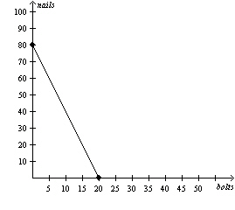
Refer to Figure 3-9. If the production possibilities frontiers shown are each for two days of production, then which of the following combinations of bolts and nails could Uzbekistan and Azerbaijan together make in a given 2-day production period? (Points :1)
12 bolts and 120 nails
24 bolts and 96 nails
38 bolts and 50 nails
44 bolts and 24 nails
13. Figure 4-8
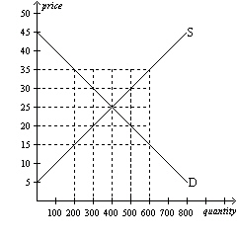
Refer to Figure 4-8. At a price of $35, (Points :1)
there would be a shortage of 400 units.
there would be a surplus of 200 units.
there would be a surplus of 400 units.
there would be a surplus of 600 units.
14. Figure 4-14
Panel (a) | Panel (b)
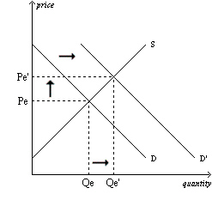 | 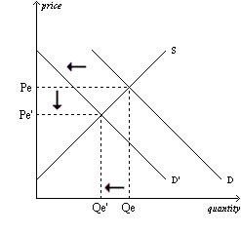
Panel (c) | Panel (d)
 | 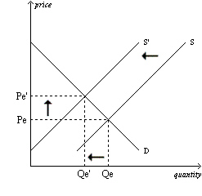
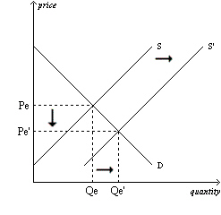
Refer to Figure 4-14. Panel (a) shows which of the following? (Points :1)
an increase in demand and an increase in quantity supplied
an increase in demand and an increase in supply
an increase in quantity demanded and an increase in quantity supplied
an increase in quantity demanded and an increase in supply
15. The price elasticity of demand changes as we move along a (Points :1)
horizontal demand curve.
vertical demand curve.
linear, downward-sloping demand curve.
All of the above are correct.
16. Figure 5-4
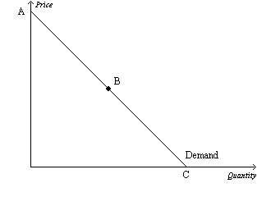
Refer to Figure 5-4. Assume the section of the demand curve from A to B corresponds to prices between $6 and $12. Then, when the price increases from $8 to $10, (Points :1)
the percent decrease in the quantity demanded exceeds the percent increase in the price.
the percent increase in the price exceeds the percent decrease in the quantity demanded.
sellers’ total revenue increases as a result.
it is possible that the quantity demanded fell from 550 to 500 as a result.
17. Figure 5-4
Refer to Figure 5-4. Assume, for the good in question, two specific points on the demand curve are (Q = 1,000, P = $40) and (Q = 1,500, P = $30). Then which of the following scenarios is possible? (Points :1)
Both of these points lie on the section of the demand curve from B to C.
The vertical intercept of the demand curve is the point (Q = 0, P = $60).
The horizontal intercept of the demand curve is the point (Q = 1,800, P = $0).
Any of these scenarios is possible.
18. Figure 5-15
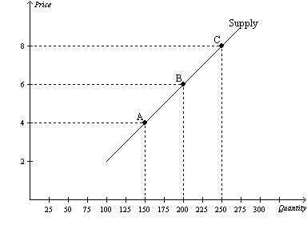
Refer to Figure 5-15. If, holding the supply curve fixed, there were an increase in demand that caused the equilibrium price to increase from $6 to $8, then sellers’ total revenue would (Points :1)
increase.
decrease.
remain unchanged.
The effect on total revenue cannot be determined from the given information.
19. Figure 5-16
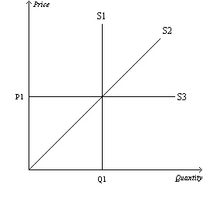
Refer to Figure 5-16. Which supply curve is most likely relevant over a very long period of time? (Points :1)
S1
S2
S3
All of the above are equally likely to be relevant over a very long period of time.
20. Scenario 5-2
The supply of aged cheddar cheese is inelastic, and the supply of bread is elastic. Both goods are considered to be normal goods by a majority of consumers. Suppose that a large income tax increase decreases the demand for both goods by 10%.
Refer to Scenario 5-2. Total consumer spending on aged cheddar cheese will (Points :1)
increase, and total consumer spending on bread will increase.
increase, and total consumer spending on bread will decrease.
decrease, and total consumer spending on bread will increase.
decrease, and total consumer spending on bread will decrease.

